6.Skull, skull of neonate and its development Vertebrae, vertebral column and its development, connections, curvatures, and motility
When discussing the skull – it is important to remember that the skull has two parts, and so the development of each part should be discussed separately – they are termed Neurocranium and Viscerocranium.

Neurocranium (vault): the parts of the cranium which is housing the brain and CNS.
Can be divided into two portions:
- Membranous part, consisting of flat bones, which surround the brain as a vault.
- Cartilaginous part, or chondrocranium, which forms bones of the base of the skull.
Membranous part- derived from neural crest cells and paraxial mesoderm. Mesenchyme from these two sources invests the brain and undergoes membranous ossification.

- Neural crest cells: providing the development of skull from the pituitary region up to frontal bone.
- Occipital somitomeres: responsible for all the parts not affected by neural crest (also base and calvaria, simply posterior bones).

Development
- Intramembranous Ossification (Direct - mesenchyme → Osteoblast → external and internal lamina of compact bone with a diploe of spongy bone in the middle): Calvaria of the skull (membranous Neurocranium): frontal, parietal and occipital
- Endochondral Ossification (indirect - mesenchyme → Chondroblast → Osteoblast): Base of the skull –(chondro-cranium): ethmoid, sphenoid and temporal
- Base of skull can be further divided (Stella Turcica as an orientation point, notochord ends there):
- Anterior to notochord (neural crest based) – Prechordal area.
- Posterior to notochord (occipital somitomeres based) → Chordal area cartilage.
Sphenoid, ethmoid, temporal, and frontal bones are pneumatized bones with air cells or sinuses.

Connections:
Primary ossification center develops in the center of the frontal/parietal/occipital bones and spread from there.
In the newborn, the different bones of the membranous cranium are connected by sutures (syndesmoses):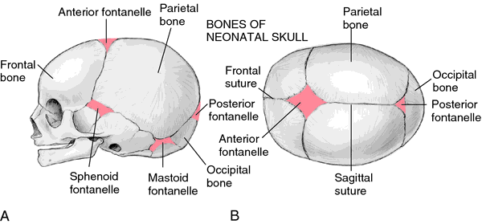
- Sagittal Suture
- Lambdoid Suture
- Coronal suture
- Squamous suture
There are some cranial synchondrosis and they are usually temporary and later become ossified.

When two sutures come together, they form a Fontanelle (sutures of more than two bones):
- anterior fontanelle (ossify at about 18 months, diamond shaped) → bregma.
- posterior fontanelle (ossify at about 3 months, triangular shape) → lambda.
- Sphenoid fontanelle - paired (6th month) → pterion
- mastoid fontanelle (18 month) - paired → Asterion (weakest part of the skull)

Clinical remarks:
- The important of suture is great during delivery (molding of the skull bones) to allow the bones of the skull to slightly overlap each other and ease the delivery.
- As the brain enlarges and grows – the bones must grow with it to occupy it in a natural way.

Viscerocranium: the part of the skull responsible for the face.
Composed of 1st and 2nd pharyngeal arches, which are rich in mesoderm and neural crest cells, all Viscerocranium bones are formed via intramembranous ossification.
The bones composing the Viscerocranium are:
- Maxillary, mandible.
- Zygomatic Bone, Nasal bone, Lacrimal bone.
- Temporal bone (Tympanic part and Styloid process).
1st Pharyngeal arch: composed of a ventral (Lower) and dorsal (upper) component:
- Dorsal component (maxillary process): maxilla, zygomatic bone, and some part of temporal bone.
- Ventral component (mandibular process):
- Meckel's Cartilage - The mesenchyme around Meckel's cartilage will undergo intramembranous ossification to form the mandible, while the cartilage will degenerate and disappear.
- Incus and malleus (stapes formed by the 2nd pharyngeal arch) – first bones to ossify.
When the baby is born, the Viscerocranium is much smaller than the Neurocranium, In the first years of growth that is a rapid growth of Viscerocranium due to the eruption of teeth and the expansion of paranasal sinuses.

Defects:
- Anencephaly – no closure of the anterior neural pore – no vault of the skull, not compatible with life.
- Meningocele – only a part of the vault is missing, dura mater comes out from the gap as a protrusion.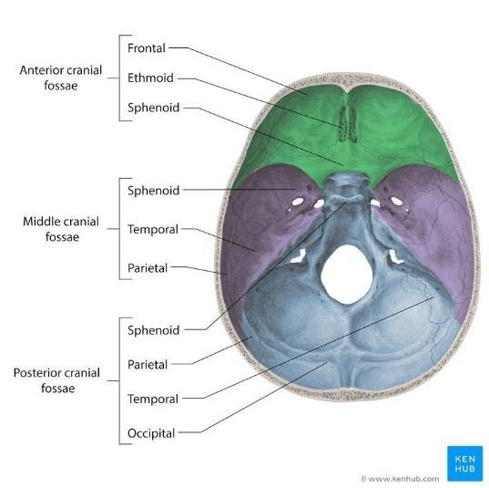
- Encephalocele – if a part of the brain herniates through a skull defect into a dura-lined sac.

Cranial fossae
Divided into three distinct part and can be referred to:
- Anterior cranial fossa: contains the frontal lobes of the brain
- Middle cranial fossa: separated from the posterior fossa by the petrous crest (superior border of the petrous part of the temporal bone).
- Posterior cranial fossa: between the foramen magnum and cerebellar tentorium (separates the cerebellum from the occipital lobes, it is an extension of the dura mater) contains the brainstem and cerebellum.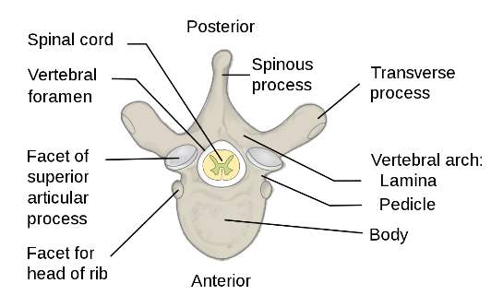

Vertebral column
33 vertebrae: 7 cervical,12 thoracic,5 lumbar, 5 (fused) sacral and (fused) 4 coccygeal.
The vertebrae are spongy bones covered by a thin layer of compact bone; the spongy bone is filled by highly hematopoietic bone marrow.
The vertebral arches consist of 2 pedicles (lateral) and 2 laminae (posterior). Together with the vertebral bodies they create the vertebral foramen → all vertebral foramina = vertebral canal (spinal cord and roots of spinal nerves → emerge through the intervertebral foramina).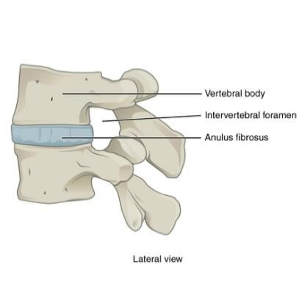
The vertebrae are connected through their articular surfaces in a joint called zygapophyseal joint (synovial, plane joints between the articular processes of two adjacent vertebrae). Plane joint- allows sliding movements three axial with limited movement. Usually has strong ligaments that limit the extent of join motion.

Type | Body | Foramen | Transverse Process | Spinous Process | Articular process
7 Cervical  C1 and C2 are different | Small, kidney shaped. | Triangular shaped | - Transverse foramen: for vertebral artery and vein.  - Groove for spinal nerve – continuation of the intervertebral foramen. | Bifid (except in C1 and C7) | Superior articular process  Inferior articular process
12 Thoracic | Heart shaped, tall as it is wide | Rounded and diamond shaped | 1. transverse costal facet – articulation with the costal tubercle of the ribs, not present on 11 and 12. | Long and points caudally | - Projects in the coronal plane, superior one points dorsally, inferior one points ventrally.  - 2 demi costal facets (superior and inferior)
5 Lumbar | Tall, wide and kidney shaped | Triangular | Costal process: embryological remnant of the lumbar ribs: mammillary processes, accessory processes. | Flat quadrate in shape when viewed from the side. | Is in sagittal plane, cranial facet points medially, caudal points laterally.
Sacral  Fused S1-S5 |  | Anterior foramina S1 – S5 fused → sacral canal  Posterior foramina → 4 pairs (anterior branch of sacral spinal nerves) | fused → lateral sacral crests | S1 – S4 Fused → median sacral crest  S5 no spinous process → sacral hiatus | Sacral cornua – articulates with the coccyx

Different shapes of vertebra are regulated by HOX genes.
Development:
Ventromedial somites (Sclerotome) paraxial mesoderm undergoes epithelial to mesenchyme transition, migrating towards the notochord and neural tube → mesenchyme tissue is formed – The mesenchyme moves medially, around notochord and around neural tube where each sclerotome will merge with the opposite sclerotome.
- Each "connection" of mesenchyme around the neural tube will form a vertebral arch- spinous process.
- Around notochord the mesenchyme will form the vertebral body.
- The segmental arrangement of the sclerotome will change (re-segmentation) – every sclerotome will divide into upper area and lower area.
- The lower half of every sclerotome fuses with the upper half of the sclerotome found beneath it. In this mechanism the mesoderm present between the two halves does not proliferate! And so, the development of vertebra is intersegmental.
- Notochord will degenerate wherever the vertebral column is developing.
- In between the vertebrae notochord will expand → forming Nucleus pulposus and so intervertebral disk will be form. The mesenchyme will form the annulus fibrosis around the nucleus pulposus.

Result:
- Spinal nerves can go between the two halves due to the gap present there.
- Muscles derived from each somite attach 2 vertebrae → mobility of the vertebral column.

Clinical remarks:
- Sclerosis – the vertebral column cannot remain straight due to various reasons.
- Spina Bifida – if the vertebral arch does not close. It has several degrees of severity according to the position of CNS:
- Spina bifida occult: no migration of spinal cord or meninges via the gap.
- Spina bifida meningomyeloseal: protrusion of spinal cord and meninges.
- Spina bifida cystica meningomyelocele: posterior neural pore does not close at all! No dura mater at the back and spinal cord is opened on the back and exposed to the surface.

Curvatures of the Vertebral Column
- Primary curvatures (Kyphosis): formed in fetal period as a result of different heights of vertebral surfaces. curves with a dorsal convexity
- Thoracic Kyphosis
- Sacral Kyphosis
- Secondary curvatures (lordosis): formed in late fetal period-infancy as a result of different heights in intervertebral disc. curves with ventral convexity.
- Cervical lordosis: develops as the child starts to use the muscles of the neck and raise its head.
- Lumbar lordosis: develops when the child stands up and learns to walk.
Clinical remarks: Scoliosis- a lateral curve of the vertebral column, pathologic when distinct. It is characterized by wedging and rotation of the vertebrae, can manifest as C type and S type.

Movements:
- Anteroposterior and lateral bending (flexion and extension) – cervical and lumbar spine.
- Rotation around an axis – mostly craniovertebral joint
Vertebral connections:
Long ligaments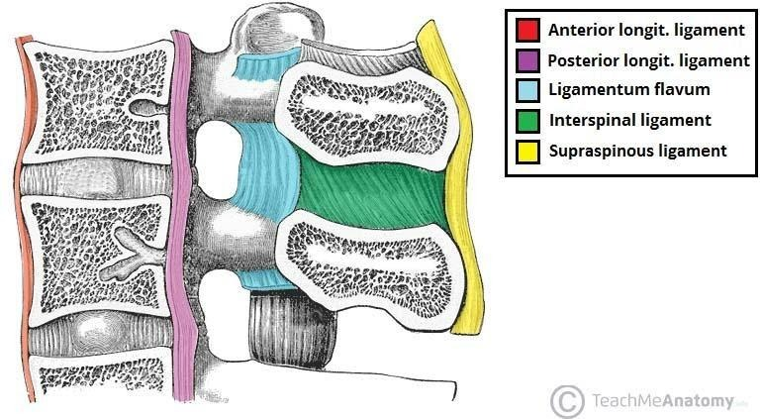
- Anterior longitudinal ligament: located on the ventral surface of the vertebral bodies C1 –S1, stabilizes and fixates the column.
- Anterior Sacro-coccygeal ligament: its caudal continuation.
- Posterior longitudinal ligament: located on the dorsal surface of the vertebra bodies inside the vertebral canal, prevents prolapse of intervertebral disks into the canal, fused with the disc all along the vertebrae.
- posterior Sacro-coccygeal ligament: its caudal continuation.
- tectorial membrane – its cranial continuation. runs through foreman magnum into the skull- covers the median atlanto- axial joint.

Zygapophyseal joint: synovial joints connecting the superior and inferior articular processes of neighboring vertebrae. There are 22 paired zygapophysial joints from the vertebrae C2-S.
Type: simple.
Shape: plane.
Movements: limited sliding movement.
Short ligaments:
- Ligamenta Flava – composed of elastic CT, they run between the vertebral arches.
Function: maintaining an erect vertebral column and allow passive extensions of the vertebral column.
- Interspinous ligament – runs in between the spinous processes of adjacent vertebrae.
- Inter-transverse ligaments – located between the transverse processes of the vertebrae.
- Supraspinous ligament – connects the tips of the spinous processes of the cervical, thoracic, and upper lumbar vertebrae.
- Nuchal ligament – the cranial continuation of the supraspinous ligaments, runs from the spinous process of C7 to external occipital protuberance.
Intervertebral disc- synchondrosis
23 discs in total, evenly distribute pressure during movements of the vertebral column, they are compressed by neighboring vertebrae to allow movements of the spine, shock absorber.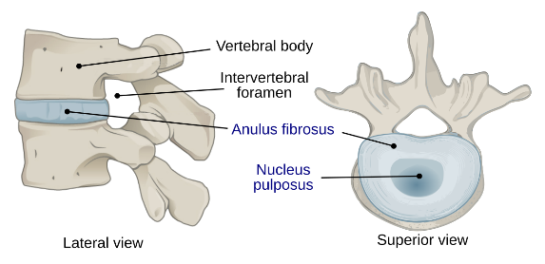
- Annulus fibrosis: a ring of fibrous cartilage, constitutes most of the mass of the intervertebral disc.
- Nucleus Pulposus: a spherical incompressible gel like substances located in the middle of the intervertebral disc.

Lumbosacral symphysis
an intervertebral disc located between the vertebrae L5 and the Sacrum, is supported by the long and short ligaments of the vertebral column.

Sacrococcygeal symphysis:
an intervertebral disc located between the sacrum and coccyx that ossifies by the 40th year. During pregnancy, this joint becomes looser due to the effect of hormone relaxin.
Herniation:
- Wear and tear – Chronic reduction of internal pressure may cause shrinkage of NP → less tension on annulus fibrosis, making it looser. Parts of the intervertebral disk maybe displaced.
- Pulposus herniation may be caused when it is pushed out to annulus fibrosus.

Synostoses-
- Synostoses of sacrum.
- Synostoses of coccyx.
8.Skeleton of thorax and its development, connections, and motility of ribs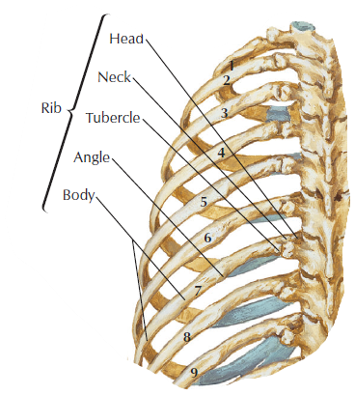
The thorax consists of sternum and twelve pairs of ribs (1-7 real – connected to sternum, 8-10 false – connect to cartilage of upper rib, 11-12 floating)

Ribs
- Head – articulates with the vertebral body.
- Articular facets (separated by crest, except for 1st ,10-12 ribs) → articulates with the costal facets on the thoracic vertebral bodies.
- Neck and body, bordered by the tubercle.
- Angle – a curvature of the rib in its dorsal third.
- Costal groove: on the inferior margin of the dorsal surface of the rib – superior border of intercostal space
- Costal Cartilage – extension on the ventral end of the ribs
- True rib's costal cartilage articulates with sternum.
- False rib's costal cartilage articulates with the next rib above.
Atypical ribs: (1,2,10,11,12)
- Rib 1 is shorter and wider than the other ribs. It only has one facet on its head for articulation with its corresponding vertebrae (there is not a thoracic vertebrae above it). The superior surface is marked by two grooves the subclavian vessels.
- Rib 2 is thinner and longer than rib 1 and has two articular facets on the head as normal. It has a roughened area on its upper surface, from which the serratus anterior muscle originates.
- Rib 10 only has one facet – for articulation with its numerically corresponding vertebrae.
- Ribs 11 and 12 have no neck, and only contain one facet, which is for articulation with their corresponding vertebrae.

Sternum
- Manubrium of sternum – the cranial part of the sternum, the origin of the sternohyoid, sternothyroid and the sternal part of the sternocleidomastoid muscles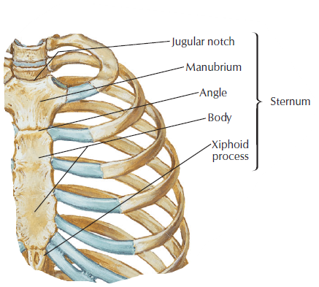
- Jugular notch – forms skin depression above the sternum called the Jugular Fossa.
- Clavicular notch –articulates with the clavicle.
- 1st Costal notch – articulates with the 1st rib
- Sternal angle of Louis – an obtuse angle between the manubrium and the body of sternum at the level of the 2nd rib.
- Body of Sternum →Costal notches – articulates with 2nd – 7th rib.
- Xiphoid process – a process of variable length and shape can be bifurcated.

Development of ribs and sternum
Ribs-
Bony portion: derived from sclerotome cells that remain in the paraxial mesoderm and grow out from the costal processes of the thoracic vertebrae. 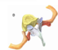
Costal cartilages: derived from sclerotome cells that migrate into the lateral plate mesoderm (ab-axial domain of lateral plate mesoderm).
Sternum-
Develops independently in parietal layer (somatic) of the lateral plate mesoderm in the ventral body wall.
Two sternal bands are formed in the parietal (somatic) layer of the lateral plate mesoderm on either side of the midline, and these later fuse to form cartilaginous models of the manubrium, sternum, and xiphoid process (by endochondral ossification).
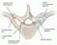
Connections and Motility of ribs

costo-vertebral joints
- Joints of head of rib – Between the ribs and the vertebrae
Articular head: the head of the rib which is divided by a small crest into two articular facets.
Articular fossa: the superior and inferior costal demi facets of the vertebral body (superior and inferior each belong to a different vertebra, one below the other).
Ligaments:
- The radiate ligaments of the head of the rib
- Intra-articular ligament of the head of the rib (in capsule)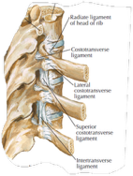

- Costotransverse joint: - Between the ribs and the vertebrae transverse process.
Articular head: tubercle of rib
Articular fossa: transverse costal facet (of same number)
Movements: Sliding movements are possible
Ligaments:
- Costotransverse ligament 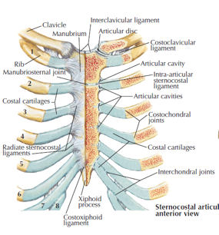
- Superior and lateral costotransverse ligaments
- 12th rib – Lumbocostal ligament (1st lumbar vertebrae to 12th rib).
Sternocostal Joints: between the ribs and the sternum.
Articular head: cartilage of 2nd – 7th rib
Articular fossa: costal notches on the sternum of the 2nd – 7th rib.
Ligaments:
- radiate sternocostal ligaments, forming the sternal membrane
- Costoxiphoid ligament – between the Body of sternum to the Xiphoid process
*1st, 6th and 7th are Synchondrosis.
Movements of the ribs expand and contract the thorax, producing the inspiration and expiration movements of breathing.
- Maximal inspiration – the expansion is made possible with the mobility in the costovertebral joint and the elasticity of the costal cartilages.
Inter-chondral joints – between the cartilages of 6th – 9th

Sternoclavicular joint between 1st rib and the manubrium
Type: ball and socket, complex.
Articular fossa: the clavicular notch on the manubrium.
Articular head: sternal articular surface of the clavicle.
Ligaments: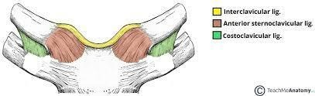
- Interclavicular
- Anterior and posterior sternoclavicular
- Costoclavicular (with the 1st rib)
Accessory features: articular disc- oval plate of fibrocartilage present in several joints which separates synovial cavities. This separation of the cavity space allows for separate movements to occur in each space.
Movement: very limited in all directions.

10.Development and growth of limb, molecular mechanisms, limb defects
The limbs, shoulders and the pelvic girdles comprise the appendicular skeleton (the bones that forms the upper and lower limbs). The appendicular skeleton develops from limb buds.
The development of the lower limb and upper limb is very similar at first, except that the lower limbs develop in a 1–2-day delay.

Proximal-distal development
- At the end of the 4th week, limb buds appear as out-pocketing from the ventrolateral body wall. Firstly, the forelimb appears and 1-2 days after the hindlimb appears.
- The limb buds consist initially of a mesenchymal core, derived from the parietal (somatic) mesoderm (lateral plate mesoderm) covered by ectoderm.
- Ectoderm at the distal end of the limb, thickens and forms the apical ectodermal ridge (AER).
This AER influences the adjacent mesenchyme (via FGF) to rapidly proliferate, but not to differentiate → undifferentiated zone (progress zone)
- As the limbs grow the cells farther from the AER (not affected by FGF) begin to differentiate into cartilage. Thus, the limb development occurs in a proximo-distal manner that can be divided into 4 components:
- Cingulum: immovable part
- Stylopod: humerus and femur
- zeugopod: ulna/ radius and tibia/fibula
- autopod: carpals, metacarpals, digits, tarsals, metatarsals
- week 6, the terminal portion of the limb buds becomes flattened forming the hand in the forelimb and footplate in the hindlimb.
- These distal and proximal portions become separated by a circular constriction (wrist, ankle).
- Later a second circular constriction divides the proximal portion into 2 segments (elbow, knee)
- The fingers of the hands and feet are formed by cell death in the AER, separating the ridge into 5 parts.
- Further development of the fingers, occurs under the influence of the 5 AER segments, causing mesenchyme to condense, form cartilage molds and ossification.
- during the 7th week the limbs rotate by 90 degrees. The lower limb rotates medially, while the upper limb rotates laterally.

Antero-posterior development
ZPA (zone of polarizing activity): special group of cells appear on the developing limb (near the distal end). This activates Sonic Hedgehog (which are responsible for specification of antero-posterior axis (thumb in anterior side)

Bone formation
- simultaneously mesenchyme in the limb buds’ condes and differentiate into chondroblasts to create hyaline models for endochondral ossification (1st model appears in week 6)
- The hyaline cartilage models go through endochondral ossification to become bone. The primary ossification centers are present in all long bones of the limbs by the 12th week.
- At birth, the diaphysis of bones is usually ossified, while the epiphysis is still cartilaginous. Shortly after birth, secondary ossification centers appear in the epiphyses.
- The epiphyseal growth plates allow elongation of the bones up to around 20 years of age.

Joints development
- In order to develop joints, the chondrogenesis arrests in some regions, and a joint interzone is induced.
- The cells in the region condense and then go through cell death to form the joint cavity. The surrounding cells differentiate to form the joint capsule.

Musculature formation
Muscle cells are derived from somites (myotomes) at specific segmental levels: upper limb C5–T2, lower limb L2-S2.
- With the formation of the limb, these cells divide to ventral (flexor) and dorsal (extensor) components.
- Later they undergo fusion and splitting processes – a single muscle may be formed from more than one original segments.
Innervation
- Ventral primary rami from appropriate spinal nerves (anterior spinal nerve) penetrate mesenchyme with dorsal (epaxial back muscles) and ventral (limbs) branches.
- Small branches unit to form large ventral and dorsal branches in each segment.
- Immediately after the nerves enter the limb buds, they establish intimate contact with the differentiating mesenchyme → very important for functional differentiation.

Molecular mechanism
- HOX genes: control the craniocaudal location of the limb bud formation (limb buds positioning)
- TBX4: specification of hindlimb. (4 limb)
- TBX5: specification of forelimb.
- Fibroblast growth factors (FGF):
- FGF10 → initiates limb growth
- FGF 4 and FGF8 → maintain undifferentiated zones.
- secreted by AER.
- BMP (bone morphogenic proteins) → induces the formation of the AER (apical ectodermal ridge).
- Expressed in the ventral ectoderm.
  - Radical fringe: restricts the AER formation to the distal tip of the limbs.
  - SHH (sonic hedgehog) → The SHH contributes to specification of anteroposterior axis.
- secreted in the ZPA (zone of polarizing activity) located in the posterior border of the limb (near AER).

Limb Defects
- Amelia- complete absence of limb.
- Meromelia- partial absence of limb.
- Phocomelia- type of meromelia, irregularly shaped bones are formed.
- Micromelia- all bones present, but super short.
- Meyomelia - abnormal in proportion
- Thalidomide – damages the AER and prevents the development of the limbs. Limb buds are very sensitive to teratogens during the 4th and 5th weeks.
- Brachydactyly- short fingers, autosomal dominant genetic disease.
- Polydactyly- extra fingers are present, usually the extra fingers lack proper muscle connections. Usually, bilateral.
- Syndactyly- fused fingers, caused by failure in the cell death process segmenting the fingers.
- Achondroplasia – The growth plate close too early during life and the limbs will always look like 3-4 YO.
- Osteogenesis, ossification, remodeling and growth of bone
Osteogenesis is the formation of a bone. The main cells active in this process are the osteoblasts – specialized mesenchymal cells that secrete osteoid. The osteoid consist initially of soft ground substance and collagen fibers.
Bones first develop as woven (primary) bones and are later being replaced by lamellar bone. The process is regulated by hormones.
Bone creation: there are two ways for the ossification of the bones.
- Desmogenic/ intramembranous ossification- the way of creation of all flat bones and the clavicles.
- Mesenchymal stem cells aggregate and form osteoblasts by difrentiation.
- The osteoblasts are coming together forming ossification center the start point of the bone, and there are collagen fibers in the matrix around the bone.
- Osteoblasts start secriting osteoid aspecialy into the ossification center- that responsible for the properties of the bone, the hardnes of the bone, but by now its an unmineralized bone. The peripherial mesenchymal cells still transform to osteoblasts.
- The osteoblast in the ossification center becoming osteocytes that responsible for maitaining the matrix that is going to be forming around the bone.
- The oseoid is calcified and hardend and makes up the bone in a number of days.
- The woven bone is fromed from the accumolationg of the osteoid in the matrix around the blood vessels, at the same time collagen fibers are concentrating as well with the mesenchymal cells creating the periosteoum- The periosteum consists of dense irregular connective tissue. It is divided into an outer "fibrous layer" and inner "cambium layer" (or "osteogenic layer").
- The woven bone is becoming the lamellea and the lamellar is dividing into the lamellar of the compact bone and the lamellar of the spongy bone. The lammelea of the compact bone is going to start forming towords the outer part of the tabicular forming the circumferntial lmellea. The internal spongy bone (the trabicular space) is going to stay there due to the fact that there is the hematopoietic process in the red bone marrow that is created from the vasscular tissue. The osteoblasts are still there because the bone is always remodelling.

- Chondrogenic/endochondral ossification- The process in which most of the bones in our body are created- all bones below the skull not including the clavicles. This process starts at the 8th embryonic week. The process step by step: 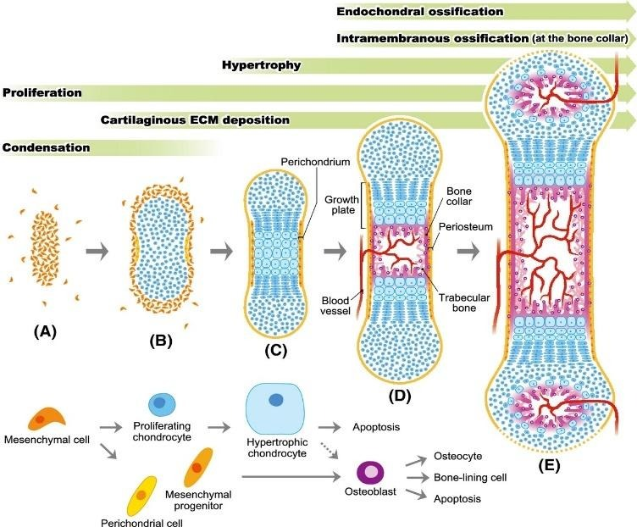
First faze:
- Mesenchyme (embryonic connective tissue) differentiates into hyaline cartilage.
- The hyaline cartilage forms a "bony" shape.
- The perichondrium around the cartilage is vascularized, causing differentiation of mesenchymal cells into osteoblasts.
- Those osteoblasts start forming a bone collar around the chondrocytes and creating primary ossification center.
Second faze:
- The bone collar blocks nutrients to the chondrocytes in the center of the diaphysis, causing them to hypertrophy and die.
- A periosteal bud (blood vessels canal) breaks through the bone collar (with the help of osteoclast) supplying nutrients to the diaphysis.
- The periosteal bud causes the formation of osteoblasts in the diaphysis which will start building bone matrix from the primary ossification center.
- Elongation of the outer compact bone and inner spongy bone is done by the osteoblasts.
- Osteoclasts migrate into the diaphysis through the circulation, starting to create medullary cavities which will house the bone marrow.
During childhood the primary and secondary ossification centers are separated by the epiphyseal disk that helps in bone elongation, in adulthood that the disk disappears, stopping bone growth.
Result-
Diaphysis- woven bone
Metaphysis- cartilaginous growth plate (ossifies at adulthood).
Epiphysis- hyaline cartilage which will go through secondary ossification after birth.
Bone remodeling
- Bone remodeling is a process that is continuous throughout life. This process is composed of two parts: bone resorption and ossification.
- Bone resorption occurs constantly by osteoclasts that break down bone, while ossification occurs constantly by osteoblasts the form bone tissue. This mechanism is the remodeling, and it usually responds to functional demands of the mechanical load on the body.
- Dysfunction of the remodeling process can cause bone metabolic diseases like, osteoporosis (weakness of bones).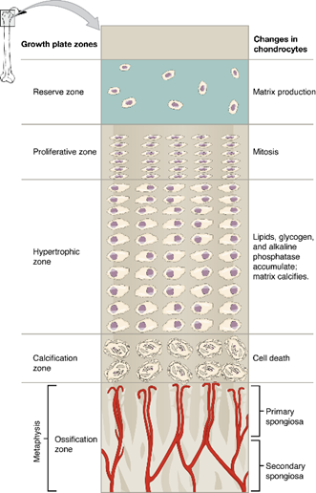
Bone growth
- After endochondral ossification of long bones, the epiphysis and the metaphysis are still composed of hyaline cartilage (not ossified).
- During infancy, secondary ossification occurs, and the epiphysis transforms from cartilage into bone.
- The metaphysis remains cartilaginous (hyaline). This cartilage will go through a process that will cause bone elongation. This process occurs from infancy to about 20 years old.
- The epiphyseal growth plate located inside the metaphysis can be divided into 4 regions (epiphyseal end → diaphyseal end): reserve zone, proliferative zone, zone of maturation and zone of calcified matrix.
- The reserve zone contains small chondrocytes and matrix. This area does not participate in bone growth, it secures the epiphyseal plate to the epiphysis.
- The proliferative zone contains larger chondrocytes than the reserve zone. In this area mitotic division of chondrocytes occurs, these chondrocytes replace the ossified chondrocytes.
- The zone of maturation is the area in which the newly formed chondrocytes from the proliferative zone mature, increasing in size.
- The zone of calcified matrix is the area in which the matrix is calcified, and the chondrocytes die. Osteoblasts and blood vessels from the diaphysis penetrates this area, forming it into bone tissue. This area connects the epiphyseal plate into the metaphysis.
**Trauma to the bone- when trauma as fracture happens to the bone. The broken ends need to be brought together as close as possible to normal position. When the bone heals, the fibroblasts in the surrounding periosteum, proliferate and secrete collagen. This forms the collar of callus to hold the bones together. Bone remodeling occurs in the fracture area and the callus calcifies, and eventually reabsorbs to be replaced by bone. After several months little evidence to the fracture is evident.

Origin and development of muscles, molecular mechanisms
Origin 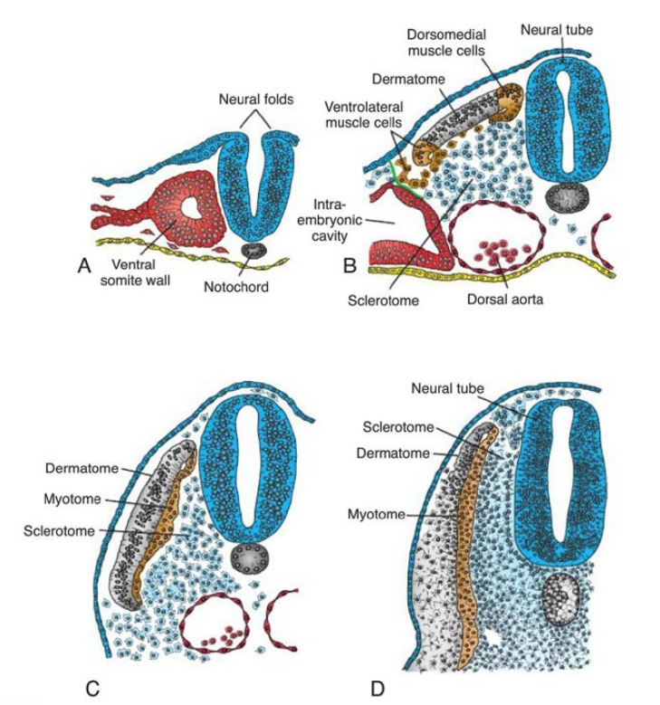
- Smooth muscle is derived from:
- splanchnic (visceral) mesoderm GIT smooth muscle
- ectodermal origin: sweat glands, mammillary gland, pupillary muscles
- Cardiac muscle is derived from splanchnic (visceral) mesoderm surrounding the heart tube.
- Skeletal muscle is derived from paraxial mesoderm – somites.
- Formed similar to skeletal muscle without the fusion of myoblasts.

Skeletal muscles
The somites undergo a process of epithelization, forming a donut shaped structure of epithelial cells. each somite differentiates to: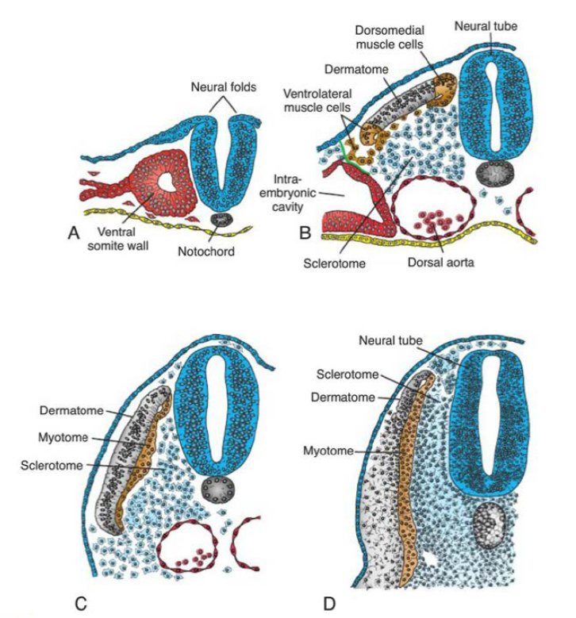
- Ventral part: sclerotome → bone-forming cells of the vertebrae and ribs.
- Upper part: dermatomes - On each side of these dermatomes are muscle-forming areas. There are 2 areas:
- Ventrolateral (VLL) muscle forming area.
- Some cells migrate to the parietal mesoderm.
- Dorsomedial (DLL) muscle forming area.
Cells from these 2 areas undergo epithelial to mesenchyme transition and migrate and proliferate ventral to the dermatome, forming the myotome (together dermomyotomes). 

Each myotome receives innervation from a spinal nerve according to its original segment. Corresponds with dermatomes as well.

Lateral somitic frontier: a distinct border (at least in the beginning) between each somite and the parietal mesoderm, separate 2 mesodermal domains:
- Primaxial domain- is the area around the neural tube, containing the somites and their derivatives.
- back and intercostal muscles, shoulder girdle
- Abaxial domain- parietal mesoderm and migrated somatic cells.
  - infrahyoid, abdominal and limb muscles
The lateral somitic frontier also separates:
- The cartilaginous parts of the ribs (parietal mesoderm) from the bony part (somite) 
- The dermis formed from the dermatome (somite) and the dermis from the parietal mesoderm.

Muscle patterning
controlled by the CT into which the myoblasts migrate:
- Head region: derived from neural crest.
- Cervical and occipital: derived from somites.
- Body wall and limbs: parietal layer of lateral plate.

Molecular mechanism
- BMP4 (Bone morphogeic proteins) and FGFs (fibroblast growth factors) together with WNT (from adjacent ectoderm)- Cause VLL cells of dermomyotomes to express the muscle specific gene- MyoD gene.
- BMP4 produced in:
  - lateral plate mesoderm
  - ectoderm → induce WNT proteins production in ectoderm (dorsal neural tube)
- simultaneously, low concentration of sonic hedgehog protein (SHH) secreted by notochord and neural tube floor plate – together with WNT cause DML cells of dermomyotomes to express MYF5 and MyoD.
MFR’s (myogenic regulatory factors: both MYF5 and MyoD – cause muscle development.

Serum response factor (SRF): smooth muscle cell differentiation.

Microscopic structure of the teeth and their development
Structure: 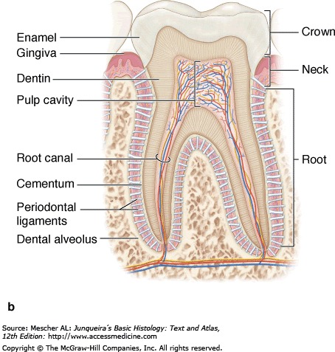
- The crown: covered by extremely hard enamel.
- The roots: covered by a bone-like tissue called cementum.
These two coverings meet at the neck of the tooth.
- The inner bulk of the tooth composed of calcified material – dentin.
- Inside the dentin capsule there is the pulp cavity, filled with pulp (soft CT)
- The pulp cavity contains the root canals and–the apical foramen (at its apical end): for entrance of the pulp's cavity blood vessels, lymphatics, and nerves.

- Enamel – a-cellular, mineralized substance.
Content: 98% in-organic salts, arranged into enamel rods without Collagen- produced by ameloblasts (only in development, not enamel production during life) 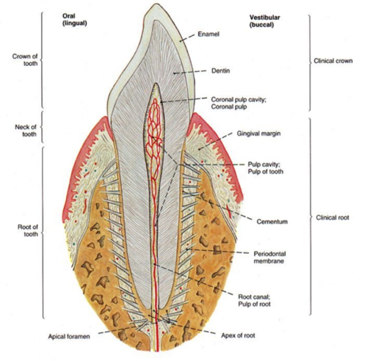
- Dentin – a hard CT constructing the bulk of the tooth (under enamel and cementum)
Produced by: odontoblasts - line the tooth's internal pulp cavity and send odontoblast processes within dentinal tubules, which penetrate the full thickness of the dentin.

Dentin ECM:
Organic component:
- Type I collagen
- Ground substance (PG and GAG)
- 70% inorganic salts (calcium hydroxypaptite)
- Pulp – loose CT. Its main components are the layer of odontoblasts, many fibroblasts, thin collagen fibrils and ground substance. The pulp is a highly innervated and vascularized - the vessels enter the apical foramen and divide into branches. The pulp nerve fibers are sensitive to pain.
- Periodontium – comprises the structures responsible for maintaining the teeth in the alveolar sockets.
- Cementum – 60-70% mineralized CT (bone-like) covering the roots of the tooth.
Thickness:
- At the neck: about 50um thick, a-cellular cementum.
- At the Apex of root: about 200um thick, cellular cementum.
production: Cementoblasts → producing the ECM on the surface of the cementum → Cementocytes (similar to the osteocytes)
- The Periodontal ligament – a CT with collagen fiber bundles connecting the cementum and the alveolar bone of the tooth socket. Unlike typical ligaments, it is highly cellular and has a rich supply of blood vessels and nerves.
- The alveolar bone – is in immediate contact with the periodontal ligament, which serves as its periosteum. It is primary (immature) bone. Many of the collagen fiber bundles of the periodontal ligament penetrate this bone and bind it to the cementum.
- The Gingiva – is a mucous membrane firmly bound to the periosteum (periodontal ligament) of the maxillary and mandibular bones, composed of stratified squamous epithelium and lamina propria. Between the enamel and the epithelium is the gingival sulcus, a groove up to 3 mm deep surrounding the neck.
Development
The teeth arise from interaction between oral epithelium) ectoderm (and underlying mesenchyme derived from neural crest.
By the 6th week of development, the basal layer of the epithelial lining of the oral cavity forms a C shaped structure - dental lamina, along the length of the upper and lower jaws.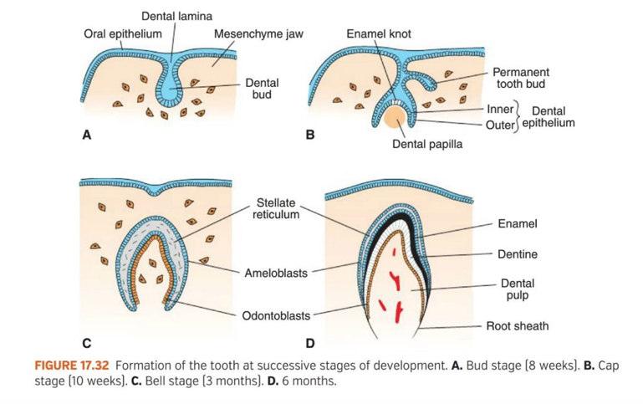
This lamina give rise to dental buds (about the 8th week), 10 in each jaw. The deep surface of the bud invaginates - cap stage (10th week)
The cap consists of:
- outer layer- outer dental epithelium
- Inner layer - inner dental epithelium
- Central core - stellate reticulum (loosely woven tissue)

The mesenchyme forms the dental papilla.
As the indentation deepens, the tooth gets a "bell" appearance - the bell stage.
Mesenchymal cells of the papilla adjacent to the inner dental layer differentiate into odontoblasts, which later produce dentin. Some of the odontoblasts retreat into the dental papilla (leaving behind thin cytoplasmic process-dental process) the remaining odontoblast persist through tooth's life- continuously produce predentin. the remaining cells of dental papilla form the tooth pulp.
In the meantime, epithelial cells of the inner dental epithelium differentiate into ameloblasts - produce enamel.
Cluster of inner dental epithelium forms- enamel knot-roll to regulate early tooth development.
Enamel is first laid down at the apex of the tooth and spreads towards the neck.
When enamel thickens, the ameloblasts retreat into the stellate reticulum.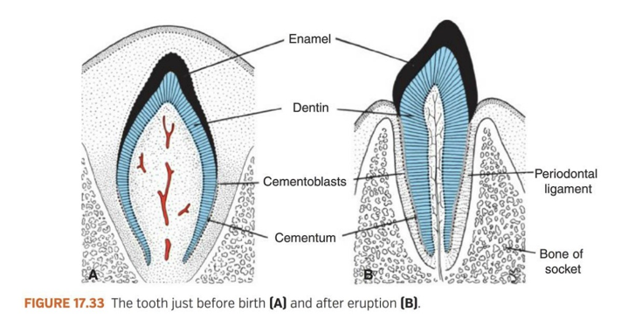
Formation of the root of the tooth begins when the dental epithelial layers penetrate into the underlying mesenchyme and form the epithelial root sheath (6th month).
Cells of the dental papilla lay down a layer of dentin (continues with that of the crown), and when more and more is deposited, it narrows the pulp chamber, leaving only a canal containing vessels and nerves.
Mesenchymal cells on the external part of the tooth that are in contact with dentin of the root, differentiate into cementoblasts - produce cementum.
Outside the cement layer, mesenchyme gives rise to the periodontal ligaments, which holds the tooth firmly in position and is a shock absorber.
The eruption of deciduous teeth occurs 6-24 months after birth.
Buds for permanent teeth are formed during the third month of development. In the age of 6, this buds of the permanent tooth begin to grow and push against the deciduous teeth, aiding them to shed.

Development of esophagus, stomach, and small and large intestine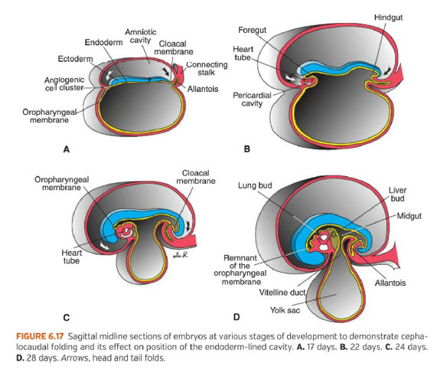
Origin:
- Endoderm – epithelial lining of GIT and parenchyma of glands.
- Mesoderm – Stroma of glands, muscles, CT, peritoneal components.
- Ectoderm – Cephalocaudal and lateral folding → Primitive Gut

Primitive gut
- Foregut→ pharyngeal gut (pharynx) Esophagus, Stomach, duodenum, liver, gallbladder, pancreas
- Midgut → Primary intestinal loop → small intestine, duodenum, large intestine (up to the Cannon- Buhm point)
- Hindgut → large intestine (from the Canonn- Buhm point), upper part of anal canal
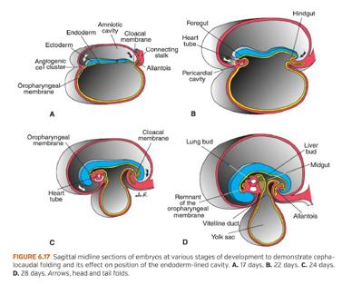
Primitive gut formation
- With development and growth of the brain vesicles, the embryonic disc begins to bulge into the amniotic cavity the lengthening of the neural tube causes it to curve cephalocaudally (into fetal position).
- Simultaneously two lateral body wall folds form and move ventrally to close the ventral body wall. The folds pull the amniotic cavity down → the embryo lies within the amniotic cavity.
- As a result of this folding, a continuously larger portion of the endoderm-lined cavity is incorporated into the body of the embryo proper.
- In the cephalic part, the endoderm forms the foregut. In the tail region, the hindgut.
- The part between foregut and hindgut is the midgut, which temporarily communicates with the yolk sac by way of broad stalk – the vitelline duct.
- At its cephalic end, the foregut is temporarily bounded by an ectodermal-endodermal membrane called the oropharyngeal membrane. (separating the primitive oral cavity – ectoderm, from the pharynx – endoderm)
- In the 4th week, the membrane ruptures, establishing an open connection between the primitive oral cavity and the primitive gut.
- The hindgut also terminates temporarily at an ectodermal-endodermal membrane – the cloacal membrane, which breaks down in the 7th week to create the opening for the anus.

The Esophagus: from foregut
- ~ Week 4: the respiratory diverticulum (lung bud) appears at the ventral wall of the foregut → at the border with the pharyngeal gut.
- Tracheo-esophageal septum gradually partitions the diverticulum from posterior part of the foregut. In this way the foregut is divided into:
- Ventral portion → Respiratory Primordium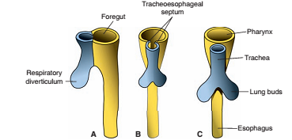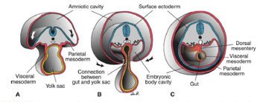
- Dorsal potion → The Esophagus.
- At first, esophagus is very short, but with descent of heart and lungs, it lengthens fast.
- The muscular coat formed by surrounding splanchnic mesenchyme.
- Straited muscle innervated by vagus n.
- Smooth muscle innervated by splanchnic plexus.

The Stomach: from foregut
Appears as a dilation of the foregut in the 4th week of development.
During the following weeks: Position and appearance change greatly as a results of different growth rates in many regions of its wall + rapid changes in surrounding organs.
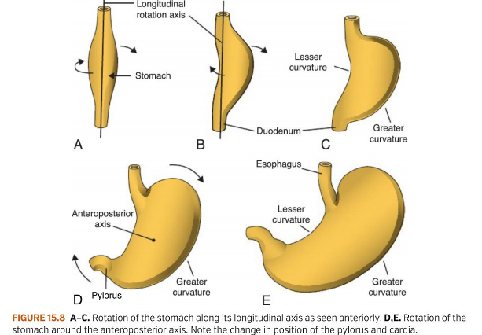
In order to best image the rotation: around a longitudinal axis and anteroposterior axis.
- The stomach rotates 90 degrees clockwise around its longitudinal axis → causing the left side to face anterior and the right side to face posterior → this is why the left Vagus nerve (that was innervating the left side) now innervates the anterior wall and the Right branch the posterior wall.
- During this rotation → Original posterior wall grows faster than anterior wall, forming the → Greater curvature and lesser curvature.
- The Cephalic + Caudal ends of stomach originally lie in the midline → Stomach grows more → rotates around anteroposterior axis → pyloric part moves to the right and upwards → Cardiac part moves to the left and downwards → Final position of Stomach.
Fixation of Stomach: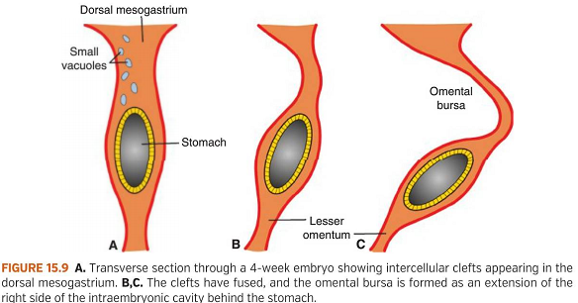
The stomach is attached to:
- Dorsal body wall → Dorsal Meso-gastrium: (greater omentum)
- Ventral body wall → Ventral Meso-gastrium.

The longitudinal rotation and disproportionate growth alter the position of these mesenteries:
- Pulls the dorsal Mesogastrium to the left → Space is created behind the stomach → Omental Bursa.
- Pulls the ventral Mesogastrium to the right → as the stomach moves → it determines the position of the spleen, pancreas, and liver.
- creates several folds and ligaments.

The Small and Large intestine:
Duodenum: from terminal part of foregut and cephalic part of midgut (junction) – distal to liver bud.
- Stomach rotation and pancreatic head rapid growth →Duodenum takes a "C shaped" form and rotates to the right → this takes the duodenum from its original position (Midline) to the right side of abdominal cavity.
- The duodenum + Head of pancreas → pressed against dorsal body wall → causing the dorsal meso-duodenum to fuse with peritoneum → both layers disappear.
This results in:
- Pancreas and most of duodenum obtain a Retro-peritoneal position.
- The pylorus of the stomach + a small portion of the duodenum (ampulla) remain intraperitoneal.
Blood supply: duodenum gets blood from superior mesenteric (mainly Midgut) + Celiac (mainly Foregut).

Histologically wise:
- During the 2nd month, the lumen of the duodenum is obliterated by proliferation of cells in its walls → the lumen is than quickly re-canalized.

Small and Large intestine – Midgut
- 5-week → midgut is suspended from: Dorsal abdominal wall by → Short mesentery and communicates with the yolk sac Via → Vitelline duct or (Yolk Stalk)
- Rapid Elongation of the gut and its mesentery → formation of primary intestinal loop + apex.
- The loop is still connected with yolk sac via the vitelline duct.
- Development:
- Cephalic part of the loop → distal part of duodenum, the jejunum and part of ileum.
- Caudal part of loop → lower portion of Ileum, into the Cecum, appendix, ascending colon and 2/3 of the transverse colon.
- During the 6th week: as a result of the intestine rapid elongation and the expansion of the liver the abdominal cavity is too small to contain all the loops → they must enter the extraembryonic cavity in the umbilical cord – temporal herniation.
- The primary intestinal loop rotates around an axis form by the superior mesenteric artery.
- Even during rotation, elongation of the small intestinal loop continues, and the jejunum and ileum form a number of coiled loops.
- the rotation occurs during herniation and the return of the intestinal loops into the abdominal cavity.
- 10th week:
- The herniated intestinal loops begin to return to abdominal cavity: Retraction occurs from left (Jejunum) to right - last enter the cecal bud to the right upper quadrant → descends to right iliac fossa.
- position of ascending colon and right colic flexure on the right side
- formation of appendix.
- Rotation continues → 180 degrees.

Large intestine – Hindgut:
Gives rise to: distal 1/3 of the transverse colon, descending colon, sigmoid, and rectum's upper part of the anal canal.
- The terminal part of the hindgut enters into the posterior region of cloaca (primitive anorectal canal).
- Cloacal membrane: boundary between the endoderm and the ectoderm.
- Uro-rectal septum: The mesoderm between the allantois and hindgut
- The hindgut gets closer to the cloacal membrane → raptures (7th week) → opening of the hindgut and urogenital sinus.
- septum between the two forms the perineal body.
- The lower part of the anal canal → from endoderm.
Development of pancreas and liver
The Pancreas from Foregut
The pancreas is formed by two buds 🡪 Ventral (forms the uncinate process, inferior part of the head of pancreas) and Dorsal (forms the rest of the pancreas) -Both originating from the endodermal lining the of duodenum.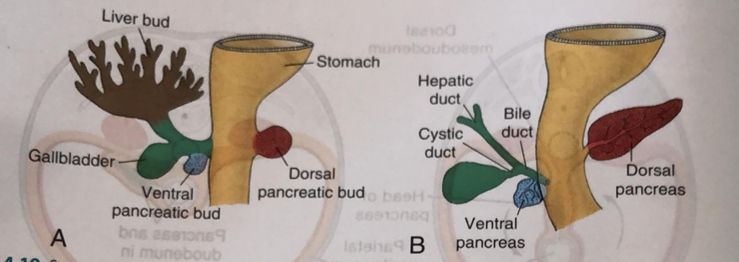
- The dorsal pancreatic bud is in the dorsal mesentery, the Ventral pancreatic bud is close to the bile duct.
- When the duodenum rotates and becomes C shaped, the ventral pancreatic bud moves dorsally in a manner similar to the shifting of the entrance of the bile duct.
- The ventral bud comes to lie immediately below and behind the dorsal bud.
- The parenchyma and the duct systems of the dorsal and ventral pancreatic bud’s fuse.
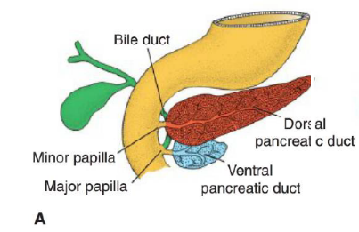
Annular pancreas: the ventral bud is made by right and left parts, occasionally the left part will migrate dorsally in the opposite direction the right (regular) resulting in the pancreas encircling the duodenum (annular). This is a rare condition in which the second part of the duodenum is surrounded by a ring of pancreatic tissue continuous with the head of the pancreas.
Ducts
- The main Pancreatic duct (of Wirsung): formed by the distal part of the dorsal pancreatic duct and the entire ventral pancreatic duct. 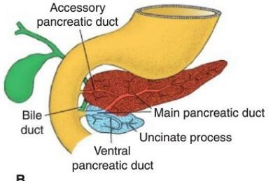
- Enters the duodenum via the major papilla together with the bile duct.
- The Accessory pancreatic duct: the proximal part of the dorsal pancreatic duct either is obliterated or persists as the accessory pancreatic duct.
- Enters the duodenum via the minor papilla.
The Pancreatic Islets:
- 3rd month: the pancreatic islets develop from the parenchymatous pancreatic tissue, and scatter throughout the pancreas.
- Insulin secretion begins at approximately 5th month.
- Glucagon and somatostatin secreting cells also develop from parenchymal cells.
- Visceral mesoderm surrounding the pancreatic buds forms the pancreatic CT.
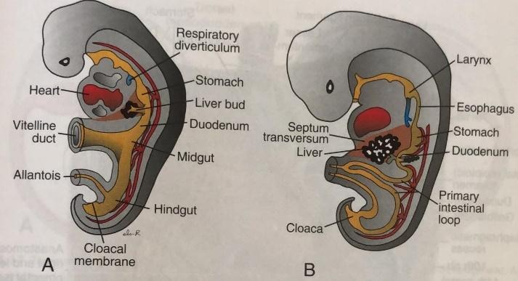
The Liver and gallbladder from Foregut
- 3rd week: liver primordium appears as an endodermal outgrowth at the distal end of foregut – hepatic diverticulum (liver bud).
- The liver bud cells proliferate very fast penetrating the Septum Transversum - the mesodermal plate under the pericardial cavity 🡪 diaphragm and ventral mesentery.
- As the cells continue to penetrate the septum, the connection between liver bud and foregut narrows 🡪 forming the bile duct.
- A ventral outgrowth from bile duct gives rise to the gallbladder and cystic duct. 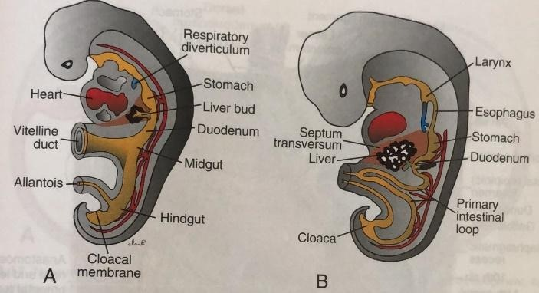
- During further development 🡪 Epithelial liver cords intermingle with vitelline and umbilical veins 🡪 the hepatic sinusoids.
- Liver cords differentiate into the parenchyma (liver cells) and form the lining of biliary ducts.
- Hematopoietic cells, Kupffer cells and CT cells are derived from mesoderm of Septum Transversum.
- After liver cells invade the entire septum Transversum - the organ bulges caudally into abdominal cavity. 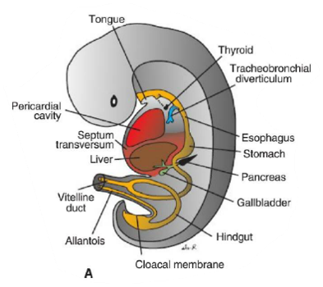
- Mesoderm of septum Transversum lying between the: (Liver and the foregut) and (liver and ventral abdominal wall) 🡪 will become membranous, forming the ventral mesentery (lesser omentum and Falciform ligament) - the connection between foregut and ventral abdominal wall.
- Bare Area: mesoderm on the surface of the liver differentiates into visceral peritoneum except on its cranial surface.
In this region, the liver remains in contact with the rest of the original septum Transversum. This portion of the septum will form the central tendon of Diaphragm. 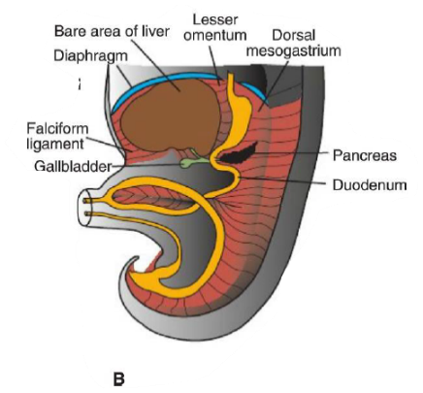
- 10th week: Hematopoiesis in the liver, gradually stops as bone marrow increases in function. Gradually subsides during the last 2 months of intrauterine life.
- 12th week: Bile formation.
Paranasal sinuses and their syntopy, their development
The paranasal sinuses are mucosa lined cavities within the bones that are adjacent to the nasal cavity. They are connected into the nasal cavities by small ostia in the lateral nasal wall through which the respiratory epithelium of the nasal cavity continues into the paranasal sinuses but, thinner and less well vascularized. All of these paranasal sinuses, except the sphenoid, communicate with the nasal cavity via ducts.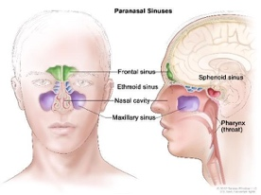
Functions:
- Increase the resonance of the voice.
- Decrease the weight of the skull.
- Produce mucous (moisten nasal cavity)
Notes-
- The paranasal sinuses are not fully developed at birth until after the growth of the permanent teeth.
- Sinusitis = inflammation of sinuses (on an x-ray, black sinus = healthy, full of air // white sinus – inflammation, full of pathological fluid).
Sinusitis can be caused by: common cold, allergy, and rhinitis (=inflammation of the mucous membrane inside the nose).

Syntopy-
Frontal sinus:
lies behind the superciliary arch of the frontal bone. A variable septum separates the right and left sinuses, usually in an asymmetrical way while deviating from the midline.
The roof and the posterior wall of the frontal sinuses is border with the anterior cranial fossa.
The floor borders with the orbit.
These are the most superior in location. They drain into the nasal cavity via the frontonasal duct, which opens to the middle nasal meatus.

Ethmoidal cells:
Numerous variable cavities separated by thin, in-complete walls within the ethmoid- forming the ethmoidal labyrinth. Each side of the ethmoidal cells is divided into anterior, middle, and posterior groups.
The largest cell, the ethmoidal bulla is located on the lateral nasal wall above the hiatus semilunaris. Its medial border is with the upper part of the nasal cavity and laterally with the orbit from which they are separated by only a paper-thin plate of bone.
They are adjacent from above to the anterior cranial fossa and from below to the maxillary sinus. Anterior and middle open to the middle nasal meatus and the posterior open into the superior nasal meatus.

Maxillary sinus:
The largest of the paranasal sinuses, completely filling the body of the maxilla.
Its roof is the floor of the orbit.
Anteriorly and latterly the maxillary sinus is bounded to the facial surface of the maxilla, posteriorly it is the maxillary tuberosity and medially it borders with the nasal cavity.
The maxillary sinus opens through the roof into the middle nasal meatus.

Sphenoidal sinus:
Lies in the body of the sphenoid behind the nasal cavity. A septum divides the variable right and left sphenoidal sinuses and it may deviate to one side.
The anterior border is with the ethmoidal cells, anteriorly and superiorly with the optic canal, posteriorly and superiorly with the hypophyseal fossa (the house of the pituitary gland) and laterally with the carotid sulcus.
Connects to the spheno-ethmoidal recess.
- The relationships of this sinus are of clinical importance – the pituitary gland can be surgically accessed via passing through the nasal roof, into the sphenoid sinus and through the sphenoid bone.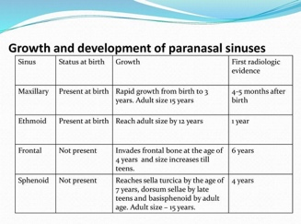

The inferior nasal concha which covers the inferior nasal meatus, the nasolacrimal duct open to.
The neurovascular supply and lymphatic drainage are as well as the nasal cavity.

Development-
Paranasal sinuses form developmentally through excavation of bone by air-filled sacs (pneumatic diverticula) from the nasal cavity. It begins prenatally and continue also during adulthood.
At birth only maxillary and ethmoid sinus are developed but not yet pneumatized.
The sphenoid sinus appears at the age of 4, and the frontal sinuses first appear at the age of 6, and fully develop during adulthood.

Internal structure of lungs - alveoli and their microscopic structure, surfactant, development, and maturation of lungs
Alveoli and their microscopic structure-
Alveoli are the terminal air spaces of the respiratory system and are the actual sites of gas exchange between the air and the blood. The surface area available for gas exchange is increased by the lung alveoli. Each alveolus is surrounded by a network of capillaries that brings blood into close proximity to inhaled air inside the alveolus.
About 150 to 250 million alveoli are found in each adult lung, their combined internal surface area is approximately 75 m2, the size of a tennis court.
Each alveolus is a thin-walled polyhedral chamber approximately 0.2 mm in diameter that is combined with an alveolar sac.
- Alveolar ducts are the distal ends of respiratory bronchioles that branch into tubes. They are completely lined by the opening of alveoli sacs. They are lined with extremely attenuated squamous cells. A strand of smooth muscle cells surrounds each alveolar opening. A network of elastic and collagen fibers supports both the duct and the alveoli.
- Alveolar sacs are spaces surrounded by clusters of alveoli. The surrounding alveoli open into these spaces. Their lamina propria is extremely thin consisting of a web of elastic and reticular fibers that surrounds the alveolar openings.
Alveoli are surrounded and separated from one another by an exceedingly thin connective tissue layer that contains blood capillaries. The tissue between adjacent alveolar air spaces is called the alveolar septum or septal wall.
Alveolar epithelium is composed of type I and II alveolar cells and occasional brush cells.
The alveolar epithelium is composed of several specialized cells and their products which play defensive and protective roles:
- Type I alveolar cells- also known as type I pneumocytes.
They are extremely thin squamous cells, they line most (95%) of the surface of the alveoli. These cells are joined to one another and to the other cells of the alveolar epithelium by occluding junctions. The junctions form an effective barrier between the air space and the components of the septal wall. Type I alveolar cells are not capable of cell division.
- Type II alveolar cells- also called type II pneumocytes or septal cells, are secretory cells. These cuboidal cells are interspersed among the type I cells but tend to congregate (להתקהל) at septal junctions. Type II cells cover only about 5% of the alveolar air surface.
Their apical cytoplasm is filled with granules, the lamellar bodies. lamellar bodies are secretory organelles. They are rich in a mixture of phospholipids, neutral lipids, and proteins, that is secreted by exocytosis to form an alveolar lining, surface-active agent called surfactant.
In addition, type II alveolar cells are progenitor cells for type I alveolar cells. After lung injury, they proliferate and restore both types of alveolar cells within the alveolus. Hyperplasia (התרבות חריגה של תאים) of type II alveolar cells is an important marker of alveolar injury and repair of alveoli.
- Brush cells- are also present in the alveolar wall, but they are few in number. They may serve as receptors that monitor air quality in the lung.
Surfactant-
The surfactant layer produced by type II alveolar cells reduces the surface tension at the air–epithelium interface. The most critical agent for air space stability is a specific phospholipid called (DPPC), which accounts for almost all surface tension–reducing properties of surfactant.
Surfactant synthesis in the fetus occurs after the 35th week of gestation and is modulated by a variety of hormones, including cortisol, insulin, prolactin, and thyroxine.
Without sufficient secretion of surfactant, the alveoli would collapse on each successive exhalation. Such collapse occurs in premature infants whose lungs have not developed sufficiently to produce surfactant, causing neonatal respiratory distress syndrome (RDS).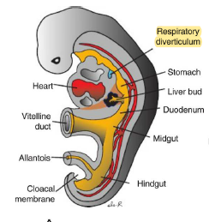

Development and maturation of lungs-
Development of Lungs:
The larynx, Trachea, Bronchi, and lungs begin to form around the 4th week.
- The Respiratory Diverticulum (Lung bud) appears as an outgrowth from the ventral wall of Foregut.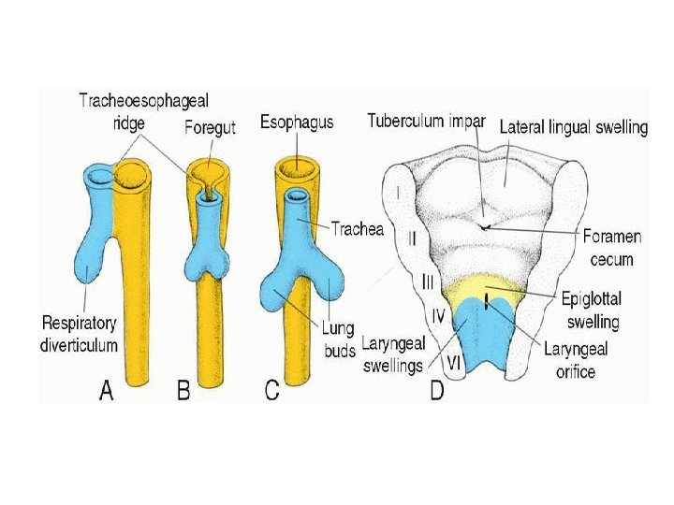
- The Lung bud, during its separation from the foregut (by tracheoesophageal septum), It forms → the Trachea and two bronchial buds.
- Epithelium of internal lining of the: Larynx, Trachea, Bronchi, and the lungs → Endodermal Origin
- Cartilage, muscular and CT components: of Trachea and lungs are from → Splanchnic Mesoderm (visceral).
- 5th week: each bud enlarges to form the right and left main bronchi buds.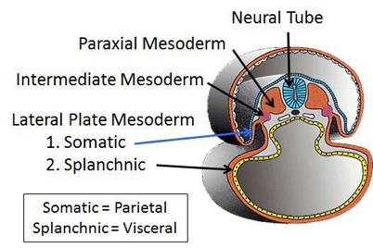
- The right bronchi bud then form three secondary bronchi, and the left forms two.
- Lung buds develop laterally-caudally and expend into the body cavity, therefor the spaces for the lungs-Peri-cardio-peritoneal canals (narrow).
- The canals lie on each side of foregut, gradually filled by expanding lung bud.
- The Pleuro-Peritoneal and Pleuro-peri-cardial folds separate the Peri-cardio-peritoneal canals from the peritoneal and pericardial cavities → the remaining spaces are forming the Primitive pleural cavities.
- The Mesoderm covering the outside of the lung → develops into Visceral Pleura.
- The somatic mesoderm layer, covering the inner body wall → becomes Parietal Pleura.
- The Space between the pleura is called the Pleural cavity.
- While new subdivisions occur (tertiary) the lungs are located more caudally, so by the time of birth the trachea bifurcation will be at level of T4.
By the end of the sixth month, approximately 17 generations of subdivisions have formed.
Before the bronchial tree reaches its final shape, an additional 6 divisions form during post-natal life.

Regulation: Epithelial-mesenchymal interactions between the endoderm of the lung buds and splanchnic mesoderm that surrounds them, regulated by various signals including Fibroblast growth factors (FGF family).

Maturation of the Lungs
Up to the 7th month:
- Bronchiole divides continuously into smaller canals (Canaliculi phase) and the vascular supply increases.
- Terminal bronchioles divide → respiratory bronchioles → each divide into 3-6 alveolar ducts → ducts end in terminal sacs (primitive alveoli –surrounded by flat alveolar cells, with close contact to capillaries)

By the end of 7th month:
There is a sufficient numbers of mature alveolar sacs and capillaries are present to guarantee good gas exchange, enabling the infant to survive.

During the last 2 months of prenatal life and for several years:
- Number of terminal sacs (promotive alveolar sacs) increases
- Cells lining the sacs are known as Type I Alveolar epithelial → become thinner, so that surrounding capillaries protrude into the alveolar sacs- creating the blood- air barrier.
- Type II alveolar epithelial cells (develops at the end of the sixth month) are producing Surfactant, phospholipid-rich fluid, and lowering surface tension at air-alveolar interface.
Mature Alveoli are not present before birth.

Before birth
The lungs are filled with fluid that contains a high chloride concentration, little protein, some mucus, and surfactant from alveolar epithelial cells (type II) → the amount of surfactant increases during the last 2 weeks.
- As respiration begins at birth, most of the lung fluid is rapidly resorbed by the blood and lymph capillaries.

Development of urinary system
Develops from the intermediate mesoderm along the posterior wall of the abdominal cavity.
Intermediate mesoderm is segmented→ Nephtotomes.

Kidneys: are formed as three overlapping kidney systems:
- Pronephros: at the 4th week, it appears as 7-10 Cell groups in the cervical region, later forms the Nephtotomes (excretory units).
Pronephros regress by the end of the 4th week (completely disappear), before more caudal units are formed - The groups of cells are forming the pronephric duct → grows caudally towards the cloaca (ventral part), becomes the mesonephric duct.
- Mesonephros: derived from intermediate mesoderm of the upper thoracic to upper lumbar segments (L3). The mesonephros creates urine between weeks 6-10, when the permanent kidney becomes active.
- Early in the 4th week of development, as the Pronephros degenerates, the first excretory tubules of Mesonephros appear.
- They then lengthen fast → forming an S Shaped loop → and gain capillaries from the aorta (forming the Glomerulus at their medial extremity).
- The Tubules then form Bowman's capsule around the glomerulus → bowman’s corpuscle.
- Laterally the tubule enters the longitudinal mesonephric duct (Wolffian duct) that connects to the cloacal.
- Middle of 2nd month: Mesonephros form a large ovoid organ on each side of the midline, and because the gonads are on the medial side, the ridge between them is called the urogenital ridge.
- End of 2nd month: majority of cranial tubules and glomeruli degenerate.
- In males a few persist and participate in formation of Genital system, in female disappear.
- Metanephros: The Definitive Kidney.
  - will develop into the definitive kidney during the 5th week from the pelvic region. When the ureteric bud penetrates the metanephric blastema.
- Branching and elongation of the ureteric bud is important for the nephron development.
- 5th week: excretory unit develop from metanephric mesoderm, replacing the degenerating mesonephric system. The metanephron creates the metanephric blastoma that secrets growth factors that causes the mesonephron duct to create a bulge- the ureteric bud. The ureteric bud secrets growth factors that help the metanephron to grow- this two way reaction is called reciprocal induction.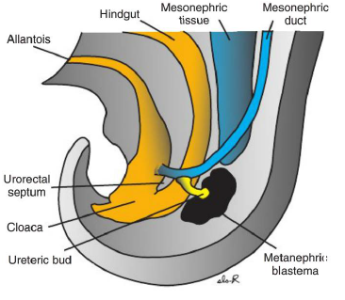

Collecting System:
Collecting ducts develop from the Ureteric Bud (outgrowth of Mesonephric duct
close to its entrance to Cloaca.
- The bud penetrates the metanephric tissue (creating the ureteric stalk that later will become the ureter as well that connects the ureteric bud to the mesonephric duct) → later it dilates, forming the primitive renal pelvis.
- The renal pelvis then splits into cranial and caudal portions (Future Major Calyces)
- Each Calyx then forms two new buds as it penetrates the metanephric tissue → they subdivide to 12 generations of tubules.
- In the periphery: more tubules form until the end of the 5th month.
- Tubules of the 2nd order enlarge and absorb the 3rd and 4th generations → forming Minor Calyces.
- Tubules of the 5th generation (and up) elongate and converge at the minor calyx → renal pyramid.
- Urine production starts soon after formation of glomerulus (around the 12th week). Until this happened the primitive urinary system from the mesonephros continues to work!!

The Ureteric bud gives rise to: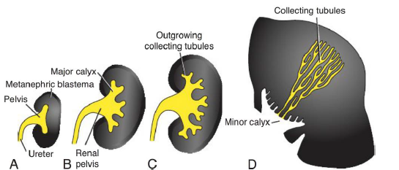
- Ureter
- Renal pelvis
- Major and Minor Calyces
- 1-3 Million collection tubules.
Excretory system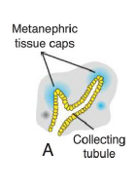
- Each newly formed collecting tubule is covered at its distal end by a metanephric mesoderm tissue cap.
- Under the inductive influence of the tubule by secretion of growth factors, cells of the tissue cap proliferate and condense to form small renal (metanephric) vesicles → give rise to small S-shaped tubules- metanephric tubule.
- Capillaries grow from the tubule into the pocket at one end of the S metanephric tubule and differentiate into glomeruli.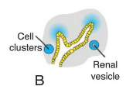
- These tubules, together with their glomeruli, form nephrons (excretory units).
- The proximal end of each nephron → Bowman’s capsule that derives from the proximal convoluted tubule, that was derived from the distal convoluted tubule that was stimulated from the collecting tubule.
- The distal end forms an open connection with one of the collecting tubules (originally from the mesonephron).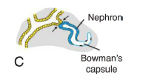
- Capillaries from the common iliac artery creates the glomeruli that interacts with bowman’s capsule.
- Continuous lengthening of the excretory tubule between the proximal and distal convoluted tubules which results in the formation of the loop of Henle.
Nephrons are formed until birth, at which time there are approximately 1 million in each kidney.
- The nephron is made from the metanephric mesoderm.
- The collecting system from the collecting tubule and farther from the ureteric bud.
Kidney position: Pelvic position (Metanephros gets blood from Pelvic branch of abdominal Aorta- common iliac) → Shifts to more cranial position in abdomen – (blood supply is from aorta at higher levels) → Growth of Body → Kidneys ascends.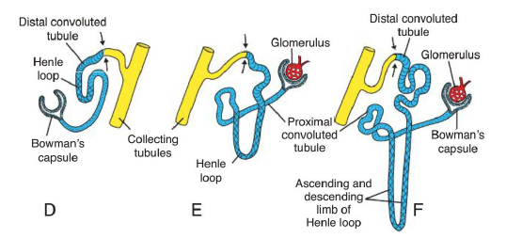
- By the 10th week the metanephron takes over the mesonephron function and produce the urine.
Bladder and Urethra: the mesonephric ducr that connects the ureter to the cloacal will split and the mesonephric duct and the ureter will join separately to the cloacal. (The mesonephric duct will later become part of the ejaculatory duct in males and the uterine tube and uterus in females).
4th to 7th week: the Cloaca divides into: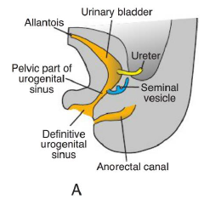
- Urogenital sinus (anteriorly)
- Anal Canal (posteriorly)
Between them the Urorectal Septum (mesoderm) is present – the tip of Septum will from the Perineal body (insertion of perineal muscles).

The Urogenital Sinus can be divided into 3:
- Urinary bladder (upper and largest part): At first the bladder is continuous with the allantois (draining the cloacal)→ Lumen of allantois is obliterated → the Urachus (thick fibrous cord) remains and connects the apex of bladder to the Umbilicus (Median umbilical ligament- remanent of the allantois).
- Pelvic part: narrow canal
- Males → Prostatic + membranous/diaphragmatic parts of Urethra.
- Female → all of urethra.
- Phallic part: flattened. As the genital tubercle grows, this part of the sinus will be pulled ventrally → development of the phallus. Primitive phallus- an object that resembles a penis.
During the differentiation of cloaca, the caudal portion of the mesonephric duct is absorbed into the wall of urinary bladder and ureters (outgrowth of mesonephric ducts) enter the bladder separately. 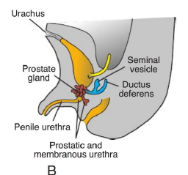
Kidneys then ascend → orifice of the ureters moves cranially, the mesonephric ducts move closer together to enter the prostatic urethra and, in the male, become → Ejaculatory ducts - Composed of Two germ layers, endoderm and ectoderm.
However, this structure will “degenerate” as mesenchyme proliferates forwards into phallus.

Urethra:
The epithelium in both sexes originates in endoderm, surrounding CT and Smooth muscle tissue is derived from visceral mesoderm.
3rd month: Endodermal epithelium of the prostatic urethra proliferates forming a number of outgrowths that penetrate the surrounding mesenchyme.
- Males: these buds are prostate gland.
- Females: cranial part of Urethra gives rise to Urethral and Para urethral glands.
Development of reproductive system
Sex differentiation is a complex process, which involves many genes. It is genetically determined at the moment of conception.
However, it is not until the 7th week that is it morphologically detectable.
The process of differentiation takes place until the 12th week, when the two sexes become fully differentiated.

The organs of both male and female genital systems can be divided into:
- Gonads
- Excretory ducts
- External Genital Organs
The key for sexual dimorphism is the Y chromosomes, which contains the testis determining gene - the SRY. Under its influence male development occurs, and without it female development is established.

Gonads:
The gonads do not acquire male or female morphological characteristics until the 7th week of development.
- The gonads appear as a pair of longitudinal ridges - The Genital ridges (formed by proliferation of epithelium and a condensation of underlying mesenchyme)
- Germ Cells do not appear in the genital ridges until the 6th week.
- 3rd week: Germ cells originate in the epiblast → migrate through primitive streak.
by the 3rd week reside among endoderm cells in the wall of yolk sac, close to allantois.
- Weeks 4 – 6: During 4th week, the cells migrate along the dorsal mesentery of the Hindgut, arriving at the primitive gonads at the beginning of 5th week, invading the genital ridges in the 6th week.
- If the cells fail to reach the ridges → no gonads will develop!
- Right before the arrival of the cells, the epithelium in the ridges proliferates and epithelial cells penetrate the underlying mesenchyme → forming cords which are called the Primitive Sex Cords (indifferent gonads – impossible to differentiate male from female)

Testis:
- under SRY gene → encodes the TDF (testis determining factor), Primitive sex cords proliferate and penetrate deep in the medulla to form the Testis (or Medullary cords). 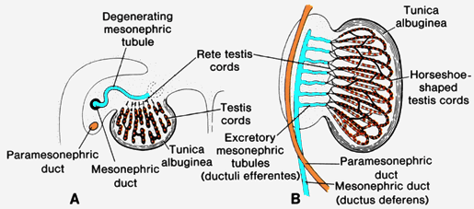
- Towards the hilum of the gland, cords break up into a network of cells → give rise to Rete Testis.
- Tunica Albuginea (dense layer of fibrous CT) separates the testis cords from the surface epithelium.
- SF1 stimulates the differentiation of Leydig cells (from mesenchyme of gonad ridge) between the testis cords.
- By week 8: produce testosterone - testis is able to influence sexual differentiation of genital ducts and external genitalia.
- 4th month: Testis cord becomes horseshoe shaped, and their extremities are continuous with Rete testis.
- Cords are now composed of primitive germ cells + Sertoli cells (derived from surface epithelium).
- Sertoli cells also produce AMH (anti-Mullerian hormone) leading to the regression of the paramesonephric duct.
- Testis cords remain solid until puberty → acquire a lumen → seminiferous tubules.
- When the seminiferous tubules are canalized, they join the rete testis tubules which enter the ductuli efferentes.
- The efferent ductulues link the rete testis and the mesonephric/ wolffian duct, which becomes the ductus deferens.

Ovary
- primitive sex cords dissociate into irregular cell clusters - contain group of primitive germ cells.
The clusters occupy the medullary part of Ovary → later they redress and are replaced by vascular stroma forming the ovarian medulla (more cortical cords develop).
- Surface epithelium (of female gonad) proliferates in 7th week → giving rise to cortical cords. 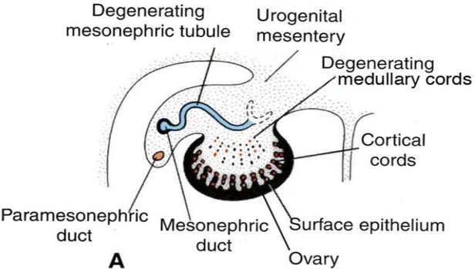
- Cortical cords penetrate the underlying mesenchyme but remain close to the surface.
- 3rd month: cords split into isolated cells clusters. Cells inside the clusters continue to proliferate and surround each Oogonium with a layer of epithelial cells called Follicular cells.
- Together, the follicular cells + Oogonium form a primordial follicle.
- Oogonia enter the 1st meiotic division and become primary oocytes.

Genital ducts:
At first → both female and male embryos have two pairs of genital ducts
- Mesonephric (Wolffian) ducts: opens into the urogenital sinus on either side of the sinus tubercle.
- Paramesonephric (Mullerian) ducts: Arises as a longitudinal invagination of the epithelium on the anterior-lateral surface of the urogenital ridge. It enters the posterior wall of the urogenital sinus → forming the Sinus Tubercle.

Genital Ducts in males: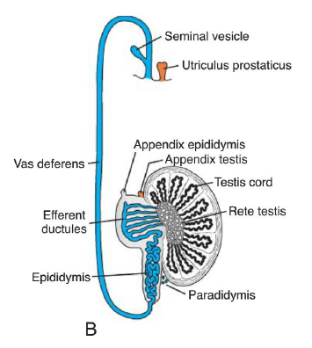
Stimulated to develop by testosterone and are derived from parts of the mesonephric (wolffian) kidney system.
- Epi-genital tubules: establish contact with cords of Rete testis → Efferent Ductules.
- Para-Genital tubules (along the caudal pole of testis): do not join with the cords of Rete testis, they are called the Paradidymis.

Except for the most cranial portion (Appendix Epididymis), the mesonephric ducts persist and form the main Genital Ducts:
- Below entrance of efferent Ductules: mesonephric ducts elongate and become Ductus Epididymis.
- From tail of epididymis to Seminal Vesicle → the mesonephric ducts form the Ductus Deferens.
- Beyond the Seminal vesicle is the Ejaculatory duct.

Under the influence of anti-Mullerian hormone (AMH) produced by Sertoli cells, paramesonephric ducts degenerate (except for a small portion at their cranial ends, the appendix testis).

Genital ducts in Females: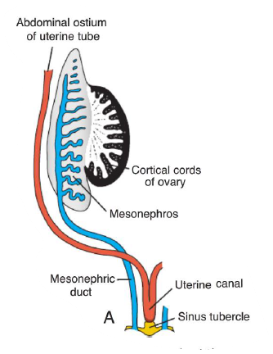
Stimulated by estrogen and absence of testosterone (no Sertoli cells= no anti- Mullerian tube)→ Paramesonephric (Mullerian) ducts develop → main genital ducts of the female. Initially, 3 parts can be recognized:
- Cranial portion: opens into abdominal cavity.
- Horizontal portion: crosses the mesonephric duct.
- Caudal portion: fuses with its partner from the opposite side.
- As the ovary descends - First Two parts Develop Uterine tube (oviduct)
- 2nd part of the Paramesonephric moves medio-caudally → urogenital ridges gradually come to lie in a transverse plane.
- Caudal portion of the first two part of the duct fuse in the midline (→ uterine canal)
- broad transverse pelvic fold is established - Broad ligament of the uterus: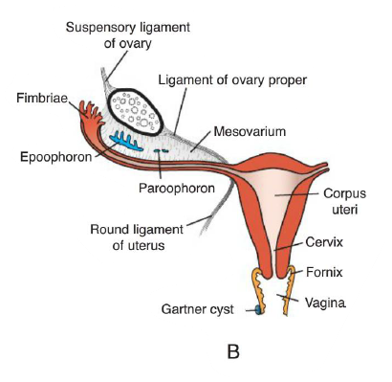
- Uterine tube lies in its upper border.
- Ovary lies on its posterior surface.
- The Uterus and Broad ligament divide the pelvic cavity into Utero-Rectal and Utero-vesical pouches.
- The fused Paramesonephric ducts give rise to Corpus and Cervix of the uterus and the upper portion of Vagina.
- They are surrounded by a layer of mesenchyme that forms the muscular coat of the uterus- the myometrium and its peritoneal covering – the perimetrium.
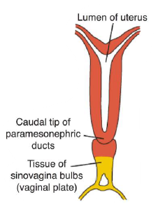
In the absence of testosterone, mesonephric ducts in the female degenerate.

Vagina – dual origin (upper portion – uterine canal, lower portion – urogenital sinus)
- After the paramesonephric ducts contacts the urogenital sinus two solid evaginations grow out from the pelvic part of the sinus – the sino-vaginal bulbs.
- The bulbs proliferate → solid vaginal plate, Proliferation continues at the cranial end of the plate.
- By the 5th month the vaginal outgrowth is completely canalized 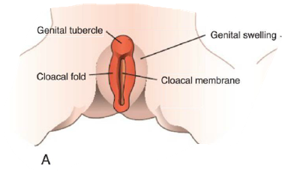
- The vaginal fornices (wing like expansions of the vagina around the end of uterus)- are of paramesonephric origin.
- The lumen of the vagina remains separated from that of the urogenital sinus by a thin tissue plate - hymen (epithelial lining of the sinus and thin layer of vaginal cells).

External Genitalia: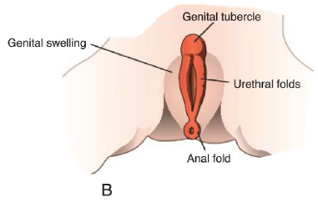
Indifferent stage
- 3rd week: Mesenchyme cells originate in the region of primitive streak migrate around the cloacal membrane to form a pair of slightly elevated cloacal folds.
- Cranial to the cloacal membrane: the folds unite to form the genital tubercle.
- Caudally: folds are divided into Urethral folds (anterior) and Anal folds (posterior).
- In the same time: the Genital Swellings (another elevated part) are visible on each side of urethral folds → later will form the Scrotal swellings in males and Labia Majora in females. 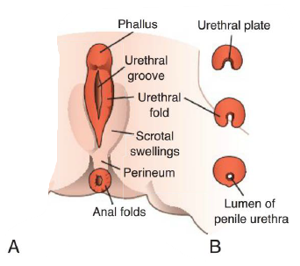

External Genitalia in Males:
Development is under influence of Androgens secreted by the fetal testes and is characterized by rapid elongation of genital tubercle → now called Phallus.
- The phallus pulls the urethral folds forwards, so they form → urethral groove.
- The groove extends along the phallus but does not reach the most distal part, the glans penis.
- The epithelium in the groove (endoderm) forms the urethral plate.
- End of 3rd month: two urethral folds close over to the urethral plate → forming penile urethra (Do not extend to tip of phallus).
- During the 4th month: the distal portion of the urethra is formed by penetration of endodermal cells from the glans penis – short epithelial cord (later canalized → external urethral meatus).
- The Genital Swellings (scrotal swellings) move caudally, and each swelling then makes up half of the scrotum. The two are separated by a septum.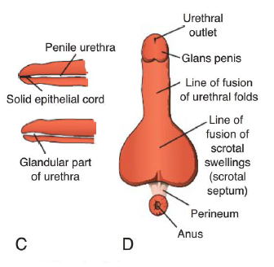
External genitalia in Female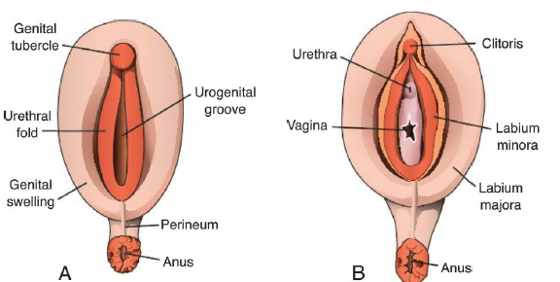
Estrogen stimulates development of the external genitalia in the female.
- The genital tubercle elongates only slightly → forming Clitoris.
- Urethral folds do not fuse but, develop into → Labia minora.
- Genital swelling enlarges and → Labia majora.
- The urogenital groove is open and forms the vestibule.

Vascular development, structure of arteries, veins, lymphatic vessel, collateral circulation
Vascular development
Blood vessel development occurs using 2 mechanisms: vasculogenesis and angiogenesis.
- Vasculogenesis: the process of formation of new vessels from cells called angioblasts.
- Angiogenesis: the process of formation of vessels from existing vessels.
The major vessels are formed by vasculogenesis (dorsal aortae, cardinal veins...).
The remainder of the vascular system then forms by angiogenesis.
The vascular endothelial growth factor (VEGF) and other growth factors are guiding the entire system.
Arterial system 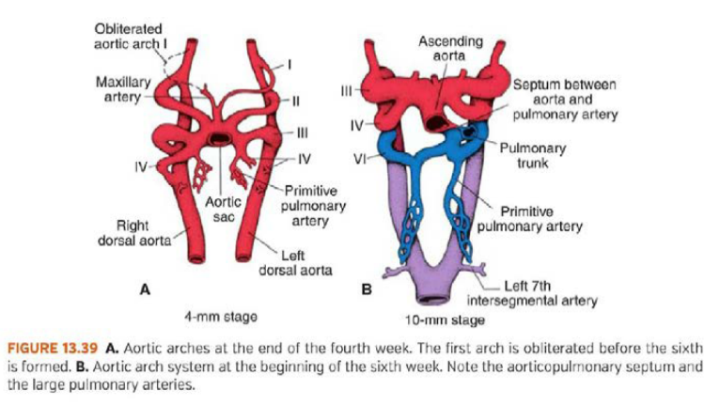
With the formation of the pharyngeal arches in the embryo (during 4th and 5th week), each of the pharyngeal arches is supplied by one cranial nerve and one artery.
Each artery is called aortic arch.

Origin: The aortic arches arise from the aortic sac (the most distal part of
The truncus arteriosus). The smooth muscle and connective tissue of these
blood vessels are formed by neural crest cells found in the pharyngeal arches.
Path: The aortic arches are embedded in the mesenchyme of the
Pharyngeal arches and terminate at the paired dorsal aortae.

The pharyngeal arches with their aortic arches, appear in cranial →caudal sequence. Thus, not all aortic arches are present simultaneously. The aortic sac contributes a branch to each new arch as it forms.

The aortic arches are numbered as: 1,2,3,4 and 6 as the pharyngeal arches (no 5!).
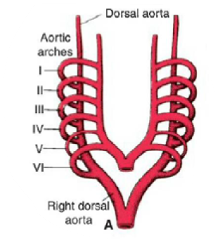
Ventral aorta
With the formation of the aortico-pulmonary septum (conotruncal) during the heart's development, the ventral aorta and the pulmonary trunk are formed.
The aortic sac gives rise to the 2 horns:
- Left horn → proximal part of the arch of aorta
- right horn → brachiocephalic artery

1st aortic arch: disappears (By day 27), leaving a small part as a remnant → forms the maxillary artery.

2nd aortic arch disappears (short after) → leaving the hyoid and stapedial arteries.
- At this point of time the 4th and 6th aortic arches are still in the process of formation. Even though the sixth arch is not completed, the primitive pulmonary artery is already present as a major branch.
- In the 29-day of the embryo the first and second aortic arches have disappeared.
- The third, fourth, and sixth arches are large.

3rd aortic arch: gives rise to:
- common carotid artery
- proximal part of the internal carotid(distal part is formed by the cranial portion of the dorsal aorta).
- The external carotid artery arises by sprouting (angiogenesis) from the 3rd aortic arch.

4th aortic arch: persists on both sides:
- on right side → the proximal part of the subclavian artery (distal part formed by right dorsal aorta and by the 7th intersegmental artery)
- on left side → part of the arch of the aorta (between the Left common carotid artery and the Left subclavian artery).

6th aortic arch: also known as the pulmonary arch.
- On right side: forms the proximal part of the right pulmonary artery
- distal part of the 6th aortic arch connecting with the dorsal aorta disappears.
- On left side: forms the left pulmonary artery,
here the distal part persists forming the ductus arteriosus (connecting ventral aorta- pulmonary trunk).

Additional changes:
- The part of the dorsal aortae known as the carotid duct (connecting the 3rd and 4th aortic arches) - obliterates on both sides.
- With the caudal descent of the heart (due to brain and neck development) the carotid arteries and the brachiocephalic artery elongate.
- The positional change of the right recurrent laryngeal nerve: The vagus nerve (and its branches) is the nerve of the 6th pharyngeal arch.
- When the distal part of the right 6th aortic arch obliterates the recurrent laryngeal nerve hooks around the right subclavian artery instead.
- This does not occur on the left side because the distal part of the artery there stays intact (and forms the ductus arteriosus).

Vitelline arteries (paired)
The arteries that supply the yolk sac (they are paired). 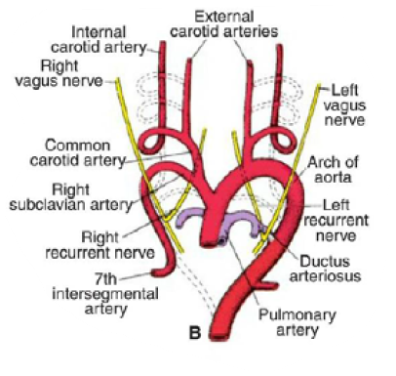
These arteries fuse and form the arteries of the dorsal mesentery of the gut.
The derivatives of these arteries in adults are the celiac trunk, inferior mesenteric, and superior mesenteric artery. They supply the foregut, midgut, and hingut.

Umbilical arteries
Initially are paired branches of the dorsal aorta.
These arteries run to the placenta carrying de-oxygenated blood.
During the 4th week, the umbilical arteries form a new secondary connection with the dorsal aorta - the common iliac artery. (The initial connection with the dorsal aorta disappears).

After birth, the umbilical arteries disappear, their remnants form:
- Proximal remnants → the internal iliac arteries and the superior vesical arteries.
- Distal remnants → the medial umbilical ligament (fold in the anterior abdominal wall).

Coronary arteries
Derived from two sources:
- Angioblasts formed elsewhere and distributed over the heart surface by migration of the proepicardial cells.
- The epicardium itself- Some of the epicardial cells undergo epithelial to mesenchymal transition, induced by the myocardium.
The new formed mesenchymal cells differentiate into the smooth muscle and endothelium of the coronary arteries. The coronary arteries endothelium invades the aorta.
- Neural crest cells form some of the smooth muscle.
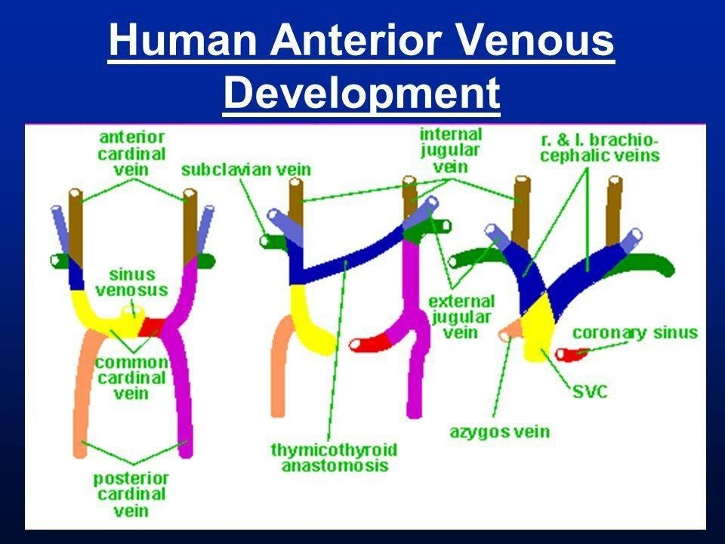
Venous system
In 5th week we able to distinguish 3paires of major veins:
- Vitelline vein- carry blood from yolk sac→ sinus venosus.
Also grows venous plexus around duodenum that after liver outgrowth from him→ hepatic sinusoid→ portal vein.
Right vitelline→ hepato-cardiac portion of IVC & superior mesenteric vein.
- Umbilical vein:
- Left umbilical vein→ round ligament.
- Right umbilical vein→ ductus venosus→ ligamentum venosum (attached to the left branch of the portal vein).
- Cardinal vein: 5th week-7th week
- Anterior cardinal veins→ left brachiocephalic & internal jugular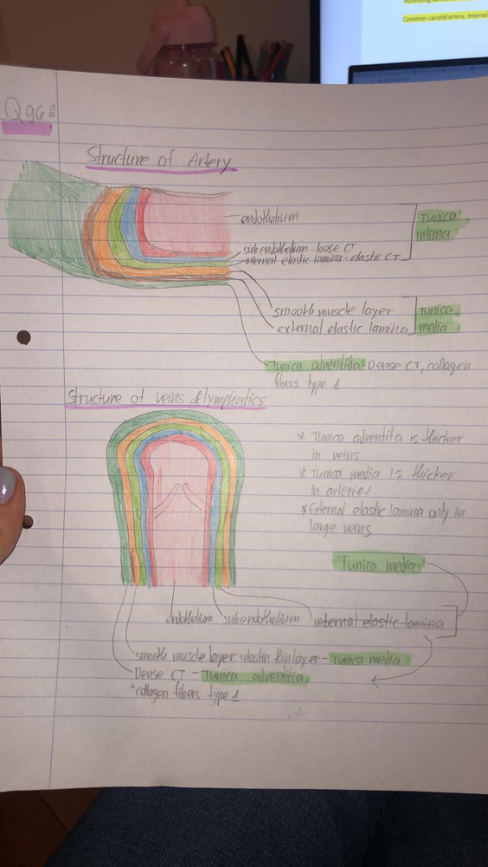
- right common cardinal & right anterior cardinal→ SVC.
- Subcardinal veins→ renal part of IVC
- Sacro-cardinal veins→ left common iliac.
- R/L supra-cradinal → azygos/hemiazygos

 | Arterial wall | Venous wall
Tunica intima | - Endothelium  - Sub endothelium  - Internal elastic lamina | - Endothelium  - Sub endothelium
Tunica media | Thickest
Tunica adventitia |  | Thickest, more smooth muscle cells
General structure and shape | Circular, thicker walls | “floppy” irregular shpae, thinner walls
Special features |  | Medium and large veins have valves
Collateral circulation:
Circulation of blood through a network of minor vessels that become enlarged and joined with adjacent vessels when a major vein or artery is impaired, as by obstruction.

Examples:
- Collateral supply of the heart muscle after a partial occlusion of a coronary artery
- Circle of Willis in the base of the brain (arteries)
- Congestion in the hepatic portal vein may give rise to collateral circulation between branches of the portal and caval veins of the liver, or between the two caval veins.

Neural tube development and its differentiation, defects of neural tube closure
Central nervous system-
Derivatives of the ectodermal germ layer-
At the beginning of the 3rd week the ectoderm appears as a disc (wider at the cephalic end that at the caudal end). The appearance of the notochord (releasing growth factors) and prechordal mesoderm induces the ectoderm to thicken (proliferation of cells), forming the neural plate. Cells of the plate make up the neuroectoderm and their induction represents the initial event in the process of neurulation.
- Neuroectoderm- pseudostratified columnar epithelium, which undergo the process of neurulation, resulting with neural crest and neural tube.
- Neurulation is the process whereby the neural plate forms the neural tube.

By the end of the third week, the lateral edges of the neural plate become more elevated to form neural folds, and the depressed and forms the neural groove. Gradually, the neural folds approach each other in the midline, where they fuse. As a result, the neural tube is formed.
Until fusion is complete (by day 21), the cephalic and caudal ends of the neural tube communicate with the amniotic cavity by way of the anterior (cranial- closed on 25th day) and posterior (caudal- closed on 27th day) neuropores.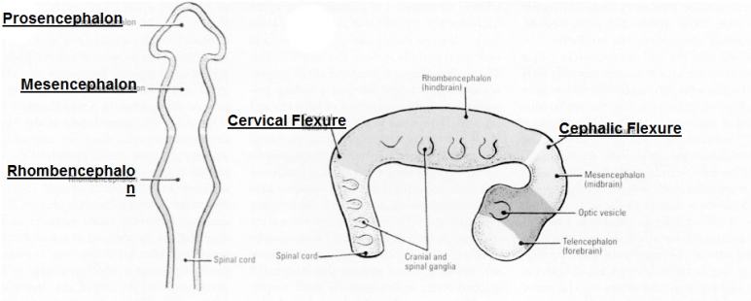
Neural tube-
Neurulation is then complete, and the central nervous system is represented by a closed tubular structure with a narrow: Caudal portion- the spinal cord and a much broader cephalic portion- the brain vesicles-
- Prosencephalon (forebrain)
- Mesencephalon (midbrain)
- Rhombencephalon (hindbrain).
Those three bulges are called primary vesicles.
The process of formation of the nervous system from the neural tube is called vesiculation.
Develop simultaneously to the neural tube differentiation:
Cephalic flexure- at level of midbrain
Cervical flexure- at the boundary between hindbrain and spinal cord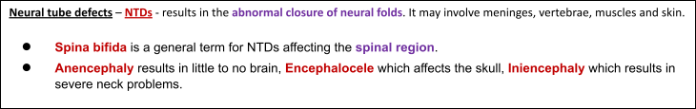
By the fifth week, the three-part cephalic brain (also called primary vesicles) consists of five parts: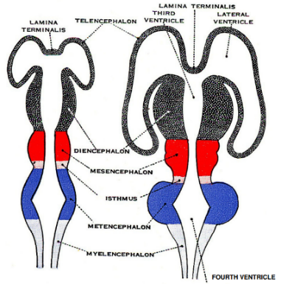
- Prosencephalon is subdivided into:
- Telencephalon – midportion telencephalon impar, two cerebral hemispheres
- Diencephalon – characterized by outgrowth of the optic vesicles.
- Mesencephalon
- Rhombencephalon is composed of
- Metencephalon – which later form pons and cerebellum
- Myelencephalon – separated by pontine flexure, forms the medulla oblongata.
Notochord realizing growth factors→ ectodermal proliferation→ creation of the neural plate→ the edge of this plate start moving towards one another (involution process) → creating neural folds and the area between called the neural groove→ closer of the neural folds to form the neural tube by day 21. 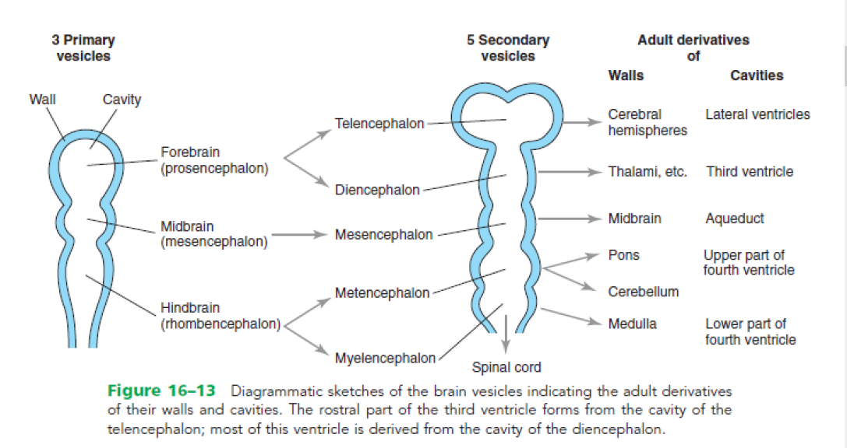
- Rhombencephalic isthmus separates the myelencephalon and the metencephalon.
- The pontine flexure marks the border between them.

Spinal cord-
The wall of a recently closed neural tube consists of neuroepithelial cells. Those cells extend over the entire thickness of the wall and form a thick pseudostratified epithelium.
Once the neural tube closes, neuroepithelial cells begin to give rise to another cell type- the primitive nerve cells, neuroblasts.
They form the mantle layer- a zone around the neuroepithelial layer, which will form the gray mater of the spinal cord.
As a result of continuous addition of neuroblasts to the mantle layer, each side of the neural tube shows a ventral and a dorsal thickening.
- The ventral thickening, the basal plates, which contain ventral motor horn cells, form the motor areas of the spinal cord.
- The dorsal thickenings, the alar plates, form the sensory areas.
- A group of neurons accumulates between the two areas and forms a small intermediate horn. This horn containing neurons of the sympathetic portion of the autonomic nervous system, it is present only in the thoracic (T1-T12) and upper lumbar levels (L2-L3) of the spinal cord.
A longitudinal groove, the sulcus limitans, marks the boundary between the two. The dorsal and ventral midline portions of the neural tube, known as the roof and floor plates, do not contain neuroblasts- they serve primarily as pathways for nerve fibers between the two sides.
In the 3rd month of development, the spinal cord extends the entire length of the vertebral column.
During development, the vertebral column and the dura matter grow more rapidly than the spinal cord → Resulting in a shift of the spinal cord more cranially. 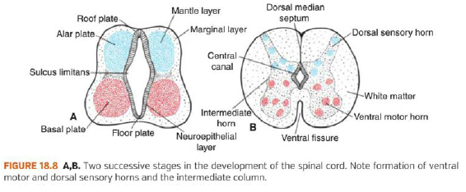
At birth, the spinal cord terminates at the level of L3. In adulthood it reaches L1-L2 → This process causes the nerve roots to run obliquely in the vertebral canal.
It also forms the filum terminale and the coccygeal ligament.
The term cauda equina refers to the descending spinal roots that run inferior to the spinal cord.

Histological differentiation-
Nerve cells-
Brain-
Distinctive basal and alar plates, representing motor and sensory areas, respectively, are found on each side of the midline in the rhombencephalon and mesencephalon. In the prosencephalon, the alar and basal plates regress.
Rhombencephalon- Hindbrain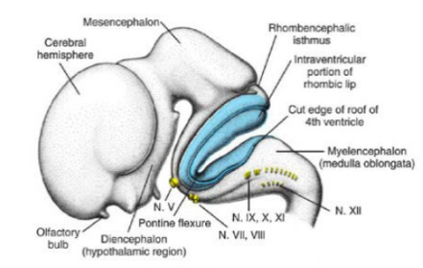
The rhombencephalon consists of the myelencephalon, the most caudal of the brain vesicles, and the metencephalon which extends from the pontine flexure to the rhombencephalic isthmus.
- Pontine nuclei- located in alar plates of both myelencephalon and metencephalon.
Myelencephalon-
Give rise to the medulla oblongata, differs from the spinal cord in that its lateral walls are everted.
The basal plate (motor nerves), similar to that of the spinal cord, contains motor nuclei. These nuclei are divided into three groups: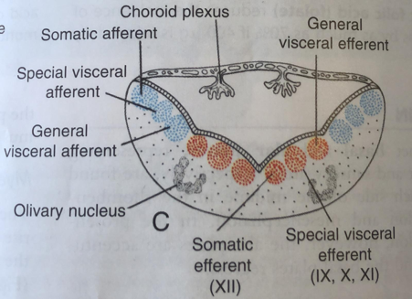
- A medial somatic efferent group.
- An intermediate special visceral efferent group.
- Lateral general visceral efferent group.
The alar plate (sensory nerves), similar to that of the spinal cord, contains sensory nuclei. These nuclei are divided into three groups:
- A lateral somatic afferent group.
- An intermediate special visceral afferent group.
- medial general visceral afferent group.
Metencephalon-
Characterized by alar and basal plates, forms the cerebellum and pons.
- Cerebellum- coordination of movement, posture, and balance center.
- Pons- pathway for nerve fibers from the cerebral and cerebellar cortices and the spinal cords.
The basal plate (motor nerves), similar to that of the spinal cord, contains motor nuclei. These nuclei are divided into three groups: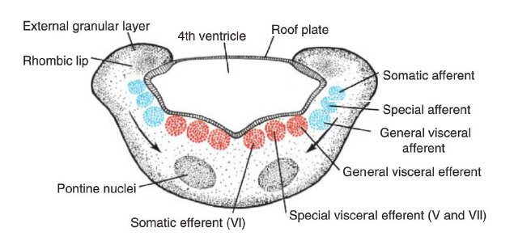
- A medial somatic efferent group- nucleus of abducens nerve.
- An intermediate special visceral efferent group- nuclei of trigeminal and facial nerves which innervates the first and second pharyngeal arches.
- Lateral general visceral efferent group- axons that supply the submandibular and sublingual glands.
The alar plate (sensory nerves), similar to that of the spinal cord, contains sensory nuclei. These nuclei are divided into three groups:
- A lateral somatic afferent group- neurons of trigeminal nerve and small portion of vestibulocochlear complex.
- An intermediate special visceral afferent group. 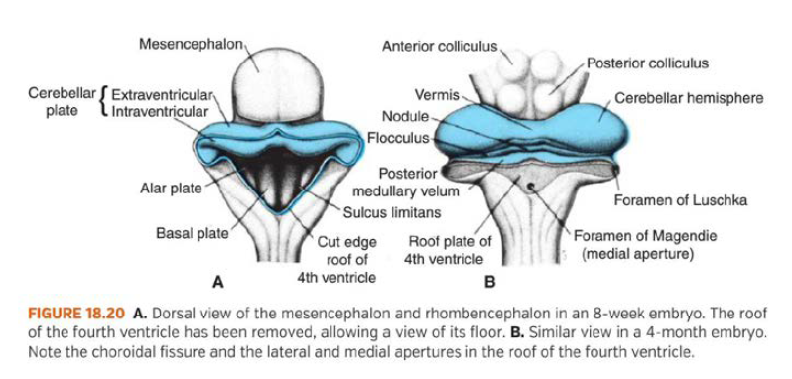
- Medial general visceral afferent group.
Development of cerebellum
- The dorsolateral parts of the alar plates bend medially, forming the rhombic lips.
- The rhombic lips compress and form the cerebellar plate.
- During the 12th week the cerebellar plate exhibits a midline portion - the vermis, and lateral portions - the hemispheres.
A transverse fissure forms in the cerebellar plate. This fissure separates the nodule from the vermis and the floccules from the hemispheres – forming the flocculonodular lobe.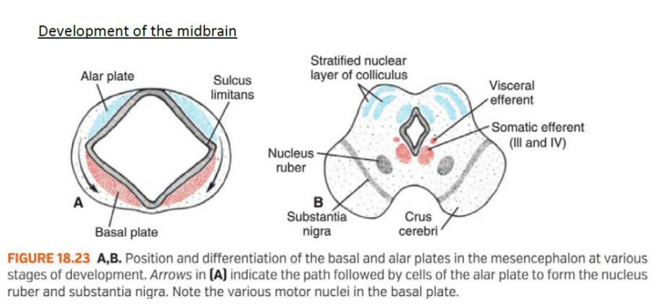
Mesencephalon- midbrain
Each basal plate contains two groups of motor nuclei:
- Medial somatic efferent (oculomotor and trochlear nerves)
- General visceral efferent (nucleus of Edinger Westphal)
The marginal layer of each basal plater enlarges → crus cerebri.

Initially the alar plates appear as two longitudinal elevations separated by a shallow midline depression.
Later a transverse groove divides each elevation to:
- Anterior (superior) colliculus: reflex center for visual impulses
- Posterior (inferior) colliculus: synaptic relay station for auditory reflex
Prosencephalon- forebrain
Consists of the diencephalon and telencephalon.
- Diencephalon- forms the optic cup and stalk, pituitary, thalamus, hypothalamus, and epiphysis (pineal gland).
- Telencephalon- forms the cerebral hemispheres.
Diencephalon- 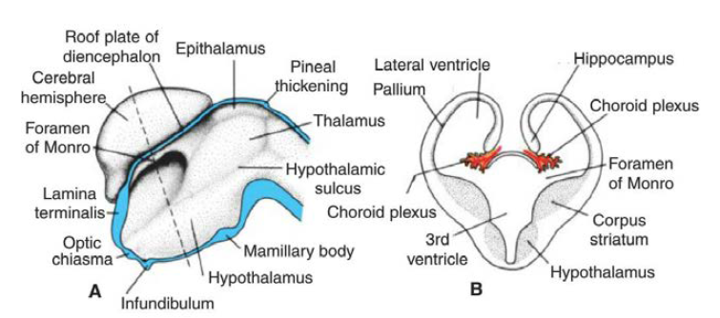
Develops from the median part of the prosencephalon.
It consists of a roof plate and 2 alar plates. It lacks basal and floor plates.

The roof plate of the diencephalon consists of a layer of ependymal cells covered by vascular mesenchyme → choroid plexus of the 3rd ventricle.
The most caudal part of the roof plate thickens to → pineal gland (epiphysis).

The alar plates of the diencephalon divide into 2 regions
- Dorsal region → Thalamus
- Ventral region → hypothalamus
The 2 regions are separated by the hypothalamic sulcus.

- The thalamus and hypothalamus will form the lateral walls of the 3rd ventricle.
- The thalamus grows with development into the lumen of the 3rd ventricle, forming a fusion of the 2 sides, known as the inter-thalamic adhesion.
- The hypothalamus differentiates into different nuclei that will take different various functions.
- One of these nuclei will protrude inferiorly → mammillary body.
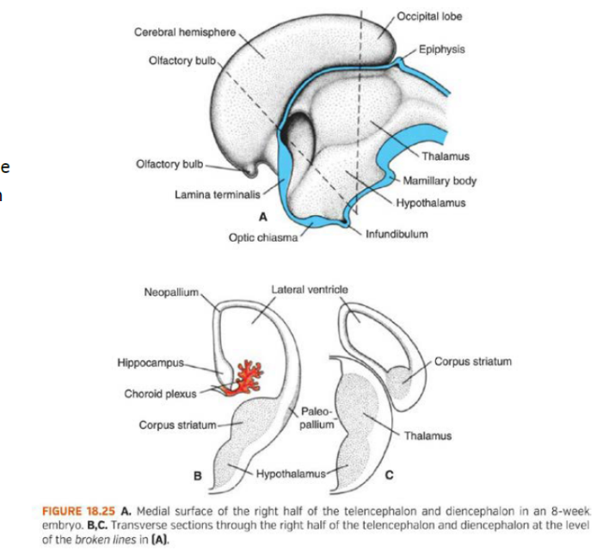
Telencephalon-
The telencephalon consists of:
- 2 lateral outpocketings - the cerebral hemispheres containing cavities (lateral ventricles)
- A median part - the lamina terminales.
- By the middle of the 2nd month: the basal part of the hemispheres begins to grow → bulging into the lumen of the lateral ventricle - This area will be the corpus striatum.
- In the region where the wall of the hemi-sphere is attached to the roof of the diencephalon – no neuroblast develop → the hemisphere will consist of a single layer of ependymal cells → choroid plexus.
- Above the choroid fissure the hemisphere thickens → hippocampus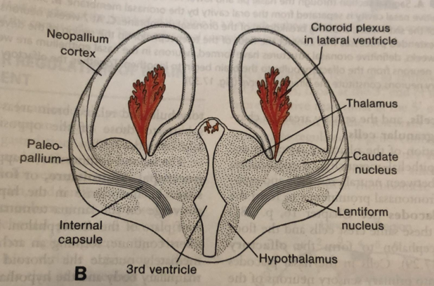
- Eventually the hemisphere covers the lateral aspect of the diencephalon, mesencephalon, and cephalic portion of the metencephalon.
- The corpus striatum expends posteriorly, divide into:
- Dorsomedial portion → Caudate nucleus
- Ventrolateral portion → lentiform nucleus

Defects of neural tube closure

Spina bifida
Spina bifida is a general term that describes neural tube defects of the spinal region.
These defects usually occur during the 4th week when the closure of the neural tube should happen.
In these defects the vertebral arches are split, and sometimes the neural tissue underneath is split as well.
- Spina bifida occulata: a defect in which the vertebral arches are not fused properly (split).
The defect usually occurs in the S1-S2 vertebrae.
The area is covered with skin, and usually covered by a patch of hair.
The defect does not usually affect the quality of life (asymptomatic).
- Myelomeningocele: a type of spina bifida occurring in the lumbosacral area. In this defect, in addition to the impaired vertebral arch fusion, the meninges and the spinal cord protrudes out of the body in a cyst like structure. 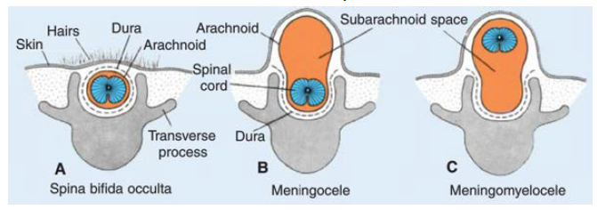
This condition causes neurological deficits, but not intellectual disability.
- Meningocele: same as myelomeningocele, but in this defect only the meninges protrude outside the body (spinal cord stays inside).

Brain defects
- Holoprosencephaly: a defect caused by a loss in midline structures.
This defect causes malformation of the brain and face.
In severe cases the eyes are fused (1 eye) and the cerebrum is not divided into 2 hemispheres.
Usually, the corpus callosum and olfactory tracts are absent.
- Anecephaly: a defect in which the cephalic part of the neural tube does not close.
Due to that, the vault of the skull does not form.
The brain tissue degenerates and become necrotic. The only part of the brain left is the brain stem. 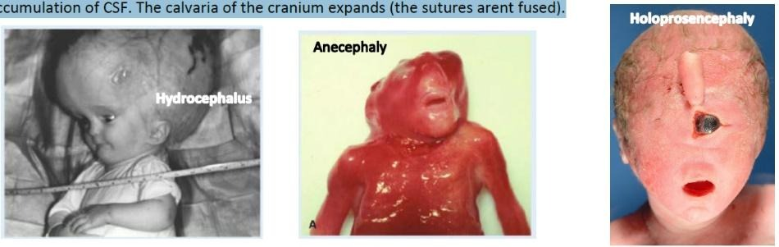
- Hydrocephalus: usually occurs in newborns due to blockage of the cerebral aqueduct.
The head's size increases due to accumulation of CSF. The calvaria of the cranium expands (the sutures are not fused).

Neural crest cells and their differentiation Ventral and dorsal spinal nerve root, dorsal root ganglion, draw general structure of the spinal nerve and its branches, autonomic fibers of spinal nerve
Neural crest derivatives
As the neural folds elevate and fuse cells at the lateral border of the neuroectoderm begin to dissociate from their neighbors. These cells, the neural crest, will undergo epithelium-to-mesenchymal transition as it leaves the neuroectoderm, by active migration to the periphery where they differentiate to varied cell types.
Cells from different regions along the anterior-posterior axis develop into different tissues, there are four main functional domains:
Cranial neural crest – migrate dorso-laterally, forms Craniofacial mesenchyme-
- Cranial ganglia and glial cells
- Craniofacial skeleton and odontoblasts
Trunk neural crest – will migrate along one of two pathways:
- dorsal pathway – through the dermis, enter the ectoderm (through holes in the basal lamina). Will form: melanocytes.
- ventral pathway – through the anterior half of each somite (sclerotome). Will form:
- dorsal root ganglia
- sympathetic ganglia
- Schwann cells
- Cells of adrenal medulla (Chromaffine cells)
Vagal and sacral neural crest – develop into:
- Enteric ganglia
- Parasympathetic ganglia
Cardia neural crest – develop into:
- Musculo-connective tissue (of large arteries)
- part of the conotruncal septum
PNS composed of spinal nerves and cranial nerves (12 pairs). Peripheral nerves derived from spinal cords are called spinal nerves. There are 31 pairs of spinal nerves:
- 8 cervical
- 12 thoracic
- 5 lumbar
- 5 sacral
- 1 cocceygeal
Peripheral nerves can carry 4 (or 5) kinds of fibers – which are functionally different: 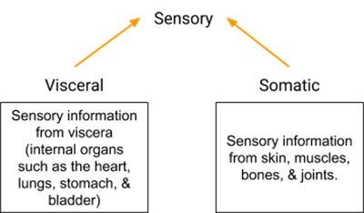
- Somatomotor (efferent) – to striated musculature of body wall and limbs – regulates movement and tension in skeletal muscles, striated muscles – voluntary.
- Somatosensory (afferent) – from the skin and musculature of body wall and limbs – gets information from mechanoreceptors, exteroreceptors, proprioceptors and thermoreceptors on body surface (skin).
- Visceromotor (efferent), autonomic – participate in regulation of activity of smooth muscle, myocardial cells and glands, blood vessels.
- Viscerosensory (afferent) – from the viscera – inner organs – transfer information from baroreceptors, chemoreceptors, and receptors from internal organs – wall tension, pain and chemical stimuli.
- Special sensory (may know as somatosensory as well) – ears, eyes.
The grey matter of spinal cord composes of 4 parts, which give rise to the four different fibers that arise from the spinal cord to form the PNS:
- Anterior horn – cell bodies of somatomotor neurons (efferent)
- Lateral horn – Cell bodies of visceromotor neurons (autonomic nervous system)
- Intermediate zone – cell bodies of viscerosensory neurons
- Dorsal horn – cell bodies of somatosensory neurons (afferent)
From the grey matter, the fibers get out through the intervertebral foramen to form two roots of spinal nerve: https://www.youtube.com/watch?v=n02mnEyWmQw
- Anterior root – Motor - contain visceromotor and somatomotor fibers – Efferent fibers
- Posterior root (through the dorsal root ganglion) – Sensory – contain viscerosensory + somatosensory fibers – Afferent fibers. 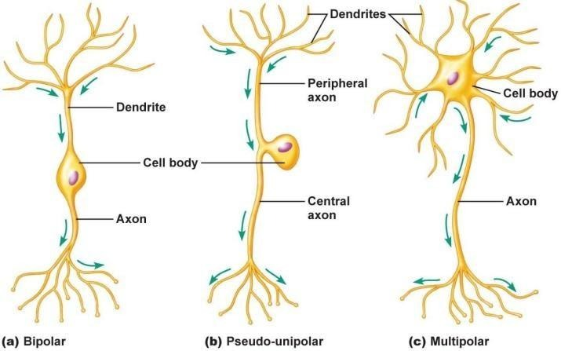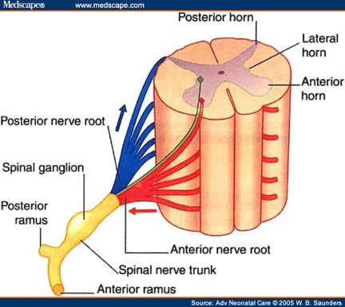
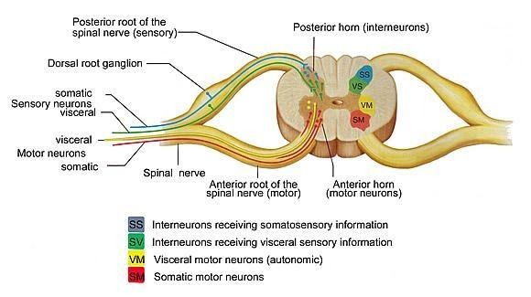
Dorsal root ganglion- (or spinal ganglion) is a cluster of nerve cell bodies (a ganglion) in a posterior root of a spinal nerve, located in the intervertebral foramina. The migrated neural crest cells form the sensory ganglia (dorsal root ganglia) of the spinal nerves.
The dorsal root ganglia contain the cell bodies of sensory (afferent) neurons. The axons of dorsal root ganglion neurons are known as afferents. In the peripheral nervous system, afferents refer to the axons that relay sensory information into the central nervous system (i.e. the brain and the spinal cord). These neurons are of the pseudo-unipolar type, meaning they have an axon with two branches that act as a single axon.
The trunk of spinal nerve is the junction, meeting point, of the anterior and posterior root, and contains all types of fibers, to form the spinal nerve which contains all type of fibers.
The trunk of spinal nerve divides into:
- Meningeal branch – extending to spinal meninges, recurrent sensory branch to annulus fibrosus.
- Anterior branch – Ventral rami – motor fibers to anterior and lateral walls of trunk and to muscles of limbs, as well as sensory fibers to corresponding skin areas. They do not retain segmental organization (with exception of skin and thoracic nerves), they form plexuses:
- Cervical plexus – C1 –C4
- Brachial Plexus – C5-T1
- Thoracic – T1-T12
- Lumbar plexus – T12-L4
- Sacral Plexus – L4-S5, Co
- Posterior branch – Dorsal rami – smaller than anterior division, supplies motor fibers to the back of the neck, trunk, gluteal region, to deep muscles of the back, as well as sensory fibers to skin areas on both sides of vertebral column. They retain the segmental form of organization – do not form plexuses.
- Communicating branch – contact with sympathetic chain ganglion. It forms two branches:
- White ramus communicans – axons with myelinated sheath – preganglionic axon
- Sympathetic ganglion (sympathetic trunk) – synapse between pre and post ganglionic neurons
- Grey ramus communicans – non myelinated axons, loop back to enter spinal nerve as post ganglionic fibers.
Autonomic fibers divided into two divisions: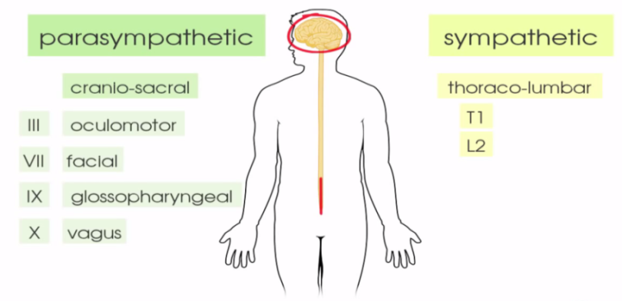
- Sympathetic
- Parasympathetic
- Enteric nervous system
In the case of sympathetic innervation, the ganglion, found in the sympathetic trunk– thus, the preganglionic neuron is really short in compare to the post-ganglionic neuron.
On the other hand, the parasympathetic pre-ganglion neuron is longer, and the ganglion found nearby the wall of the target organ. Thus – the postganglionic neuron is relatively short.
Sympathetic:
Efferent – cell bodies found in lateral horn of thorcolumbar T1 – L2 vertebrae- thoraco- lumbar outflow, and the preganglionic neuron gets out from the ventral horn to synapse with the ganglia located laterally and nearby the vertebral column – paravertebral ganglia of sympathetic trunk. Ganglia are collection of neuronal cell bodies.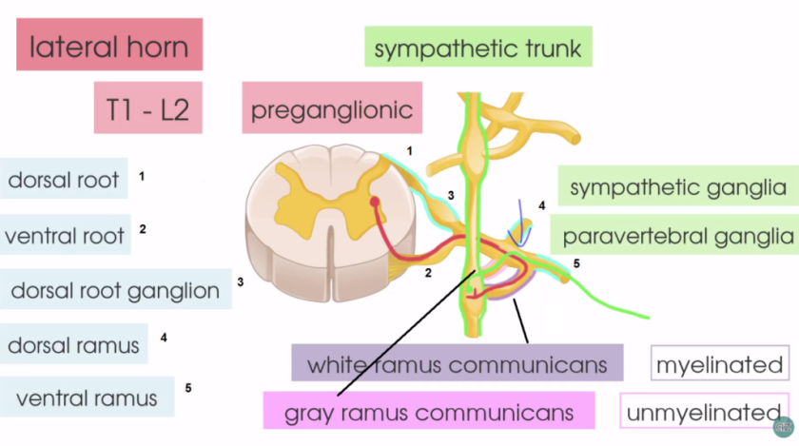
- Dorsal root- carries sensory information into the spinal cord.
- Ventral root- caries efferent motor information

From the ventral root, the neuron gets out and synapse with ganglion of the sympathetic trunk through the white ramus communicans – which is myelinated (therefore – white) and then the post-ganglionic neuron leaves the ganglion to join back with the spinal nerve through the gray ramus communicans – which is unmyelinated (thus gray), then follow to the ventral ramus to supply its target organ.

There are another mechanisms of distribution: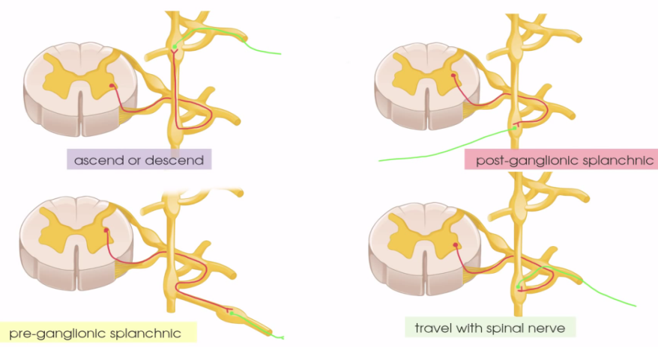
- Ascending\Descending type - Sympathetic fibers that ascends to paravertebral ganglia of cervical region (cervical spinal nerve do not contain autonomic fibers): after the synapse, the post-ganglionic fibers ascend through sympathetic trunk, enter cervical spinal nerve through grey communicating branch: sympathetic fibers to heart, parotid gland, salivary gland etc…
- Autonomic fibers that do not join the spinal nerve – they form their own nerves, these are the splanchnic nerves – start as preganglionic fibers, and after pass in prevertebral ganglion (celiac plexus, superior mesenteric plexus, renal plexus….) they become post ganglionic.

The afferent fibers of the autonomic nervous system, which transmit sensory information from the internal organs of the body back to the central nervous system (or CNS), are not divided into parasympathetic and sympathetic fibers as the efferent fibers are. Instead, autonomic sensory information is conducted by viscerosensory fibers.

Parasympathetic: The parasympathetic nervous system has cranial and sacral components- cranio-sacral outflow.
The cranial outflow of the parasympathetic components found in the nerves, cell bodies found in brain stems (gets out from the rhomboid fossa):
- III – Oculomotor
- VII – Facial
- IX – Glossopharyngeal
- X – Vagus – the largest component

The Sacral component:
Arises from spinal segments S2-S4 and gives rise to Pelvic Splanchnic nerves.
In this region the parasympathetic nervous system innervates:
- Muscles of the rectum - inhibits the internal anal sphincter.
- stimulates the bladder wall detrusor muscle, inhibits the internal urethral sphincter.
- In genital system – Point and Shoot – Para – erection, Sympa – Ejaculation.
Efferent – cell bodies in gray matter of S2-S4. There are no lateral horns, these cells send axons that leave through anterior ramus (visceromotor fibers) to form pelvic splanchnic nerves, preganglionic fibers synapse near viscera they innervate - in hypogastric plexus, or in cranial nerve ganglia – submandibular, pterygopalatine, otic, ciliary ggl.
Afferent fibers – as sympathetic, cell bodies either found in posterior root ganglia or sensory cranial ganglia.
Eye development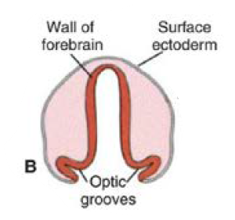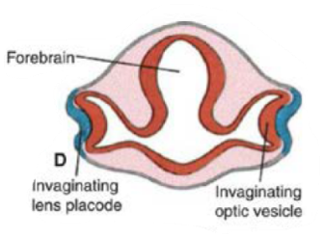
Formation of the primordial eye
The eyes develop from 4 different sources: neuroectoderm of the brain, surface ectoderm of the head, mesoderm between layers, and neural crest cells.
- The developing eyes appear on the day 22 as a pair of optic grooves on the sides of the forebrain.
- When the neural tube closes, these grooves form out-pocketing of the forebrain, the optic vesicles. 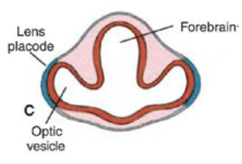
- The optic vesicles induce changes in the overlaying surface ectoderm - These changes thicken the ectoderm and form the lens placode: the primordia of the lens.
- The lens placode and the optic vesicle start to invaginate the underlying tissue → Forming the double-walled (inner wall and outer wall) optic cup.
- The intraretinal space is formed between the 2 walls. This space disappears shortly after.
- The choroid fissure is formed by invagination in the inferior part of the forming eye. The hyaloid artery runs through this fissure to supply the forming eye.
- This fissure fuses during the 7th week, and the round opening of the optic cup stays, and will become the future pupil. 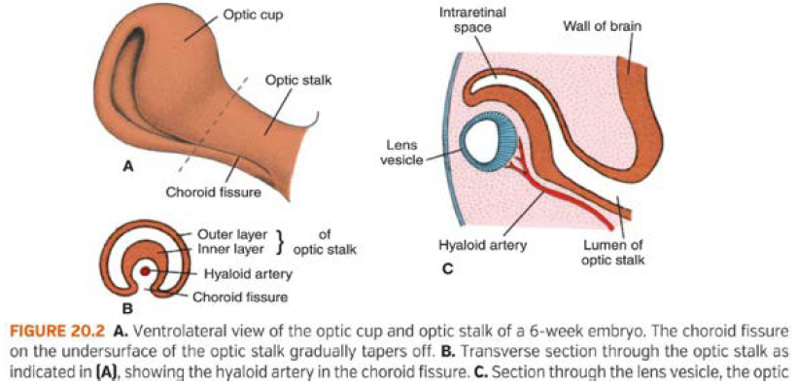
- With further development of the lens placode, it detaches from the surface ectoderm during the 5th week → The lens vesicle is formed.

Formation of the retina, iris, and ciliary body
Retina
- The outer wall of the optic cup is characterized by small, pigmented granules → pigmented epithelium. 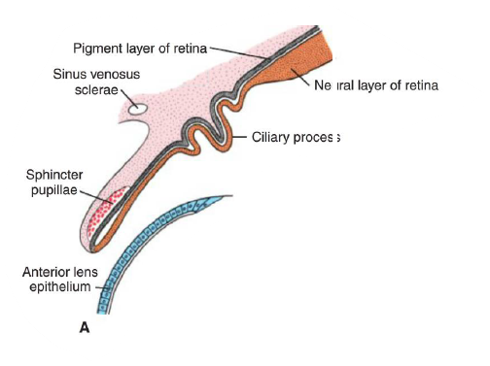
- The inner wall of the optic cup differentiates into the neural layer of the retina → It will give rise to the photoreceptor cells (rods and cones), bipolar neurons and multipolar neurons.
Pupil muscles
The region between the optic cup and the surface epithelium, starts to fill by loose mesenchyme - In this region the sphincter pupillae and dilator pupillae muscles, develop from the surface ectodermal tissue.
Iris
Formed by the pigmented epithelium, non-pigmented epithelium and the highly vascularized CT that contains the pupillary muscles. 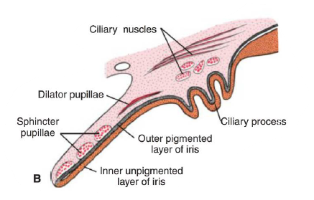
Ciliary body
Formed internally by the ciliary part of the retina is covered externally by mesenchyme that differentiates into the ciliary muscle. The mesenchymal part attaches the lens by the zonular fibers.

Formation of the lens
- shortly after the formation of the lens vesicle, cells of the posterior wall elongate anteriorly, forming long fibers that fill the lumen of the vesicle.
- By the end of the 7th week these primary lens fibers reach the anterior wall of the lens vesicle.
- Later, cuboidal cells in the central area of the lens elongate, lose their nuclei, and become secondary lens fibers - secondary lens fibers continue to form after birth.

Formation of the choroid, sclera, and cornea
Choroid and sclera
At the end of the 5th week the eye is completely surrounded by mesenchyme → The mesenchyme differentiates into an inner layer and an outer layer.
- Inner layer: highly vascularized pigmented layer (may be compared with the pia matter) → choroid.
- Outer layer: develops to be the sclera - continuous with the dura matter of the optic nerve.
Anterior chamber
Differentiation of mesenchymal layers overlying the anterior aspect of the eye is different:
The anterior chamber forms through vacuolization and splits the mesenchyme into
- Inner layer: in front of the lens and iris - the irido-pupillary membrane
- Outer layer: continuous with the sclera - the substantia propria of the cornea
The anterior chamber itself is lined by flattened mesenchymal cells.
Cornea
Develops of 3 origins.
- Anteriorly: epithelial layer from the surface ectoderm
- Middle layer: stroma formed by the substantia propria (mesenchyme) – continuous with sclera.
- Posterior corneal endothelium: borders with the anterior chamber

The iridopupillary membrane in front of the lens disappears completely→ Posterior chamber: the space between the iris anteriorly and the lens and ciliary body posteriorly.
Anterior and posterior chambers communicate with each other through the pupil and are filled with fluid called the aqueous humor.

Formation of the vitreous body
The mesenchyme is not only present around the primordial eye, it also enters the eye cavity through the choroid fissure.
- Here it develops the hyaloid artery that supplies the inner parts.
- The mesenchyme also forms a network of fibers between the lens and the retina. The interstitial spaces of these fibersare filled by a clear gelatinous substance - the vitreous body.
- The hyaloid artery degenerates and leaves the hyaloid canal as a remnant.
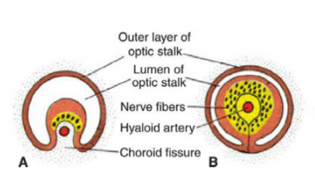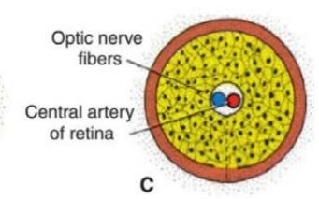
Formation of the optic nerve
- The optic cup connects to the brain via the optic stalk, which contains the choroid fissure.
- The nerve fibers of the developing retina pass through the inner wall of the optic stalk.
- With the closure of the choroid fissure during the 7th week and the increase in the number of the nerve fibers, the inner wall of the optic stalk grows.
- The inner walls and outer walls of the optic stalk fuse → forming the optic nerve.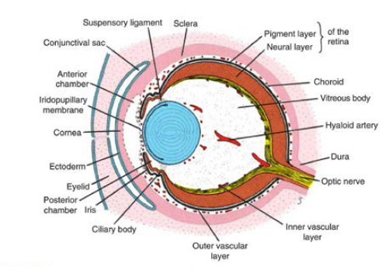
- The inner wall contains neuroglia that support the nerve fibers.
- The outer walls differentiate into dura (continuous with the sclera), arachnoid and pia matter (continuous with the choroid).

Suprarenal gland - structure and developmental origin of cortex and medulla, function, syntopy (draw scheme), blood supply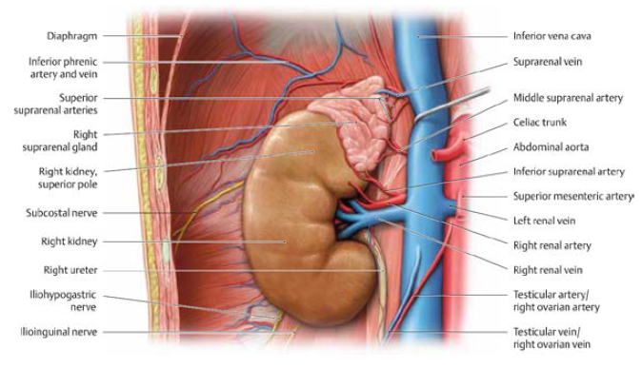
Found on top each kidney, surrounded by fibrous CT capsule and adipose tissue.
Contains cortex and medulla.

Syntopy
Right adrenal gland:
Anterior: liver
Posterior: diaphragm
Inferior: kidney
Superior: diaphragm
Medial: IVC

Blood supply
- Superior suprarenal artery: branches of the inferior phrenic artery (T12)
- Middle suprarenal artery: branches from the abdominal aorta (L1)
- Inferior suprarenal artery: branches from the renal artery (L1)
Venous drainage: blood in each gland collected into a single central vein → exits the hilum →
- Left suprarenal vein →drains to the renal vein
- Right suprarenal vein → drains into the IVC 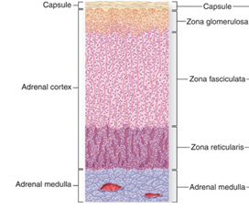

Cortex
Origin: mesoderm
Secretion: Steroid-hormone - diffuse freely through the plasma membrane and do not require exocytosis to be released from the cells.

Layers of the cortex: (Salt – Sugar – Sex).
- Zona glomerulosa (15% of cortex): Superficial
- secretion: mineralocorticoids – affect uptake of Sodium-Potassium and water by epithelial cells → mainly aldosteron
- aldosterone (main) – salt balance regulator: acts to stimulate sodium reabsorption in the distal convoluted tubules of the kidneys.
- Zona fasciculata (65-80% of cortex): Middle
- structure: long cords of large polyhedral cells filled with cytoplasmic lipid droplets and separated by fenestrated sinusoidal capillaries.
- Secretion: glucocorticoids (main secretion): mainly cortisol
- cortisol –primarily affect carbohydrate metabolism, it is also suppresses aspects of the immune response, including cytokine release and lymphopoiesis.
- small amount of gonadocorticoids.
- Zona Reticularis (10% of cortex): Deep
  - Structure: Smaller cells in a network of irregular cords
  - Secretion:
    - Small number of glucocorticoids (cortisol)
    - Gonadocorticoids: estrogen, progesterone (main) and androgen converted to testosterone in other tissues.
Medulla:
The adrenal medulla is composed cords of cells and supported by a reticular fiber network.
Cells: Chromaffin cells - arise from neural crest: neurons that lost their axon and dendrites → modified into secretory cells
Blood supply: Arteries are running through the cortex towards the medulla are called perforating arteries.
To bring blood from the capsule to the medulla.
Secretion: Chromaffin cells, contain granules with one of the catecholamines: epinephrine or norepinephrine
Release: Epinephrine and norepinephrine are released to the blood in large quantities during intense emotional reaction – fight or flight
During normal activity, the adrenal medulla continuously secrets small quantities of the hormones.

